WARM-UP / REVIEW
- Label each diagram as either:
ENDOCRINE SIGNALING PARACRINE SIGNALING SYNAPTIC SIGNALING

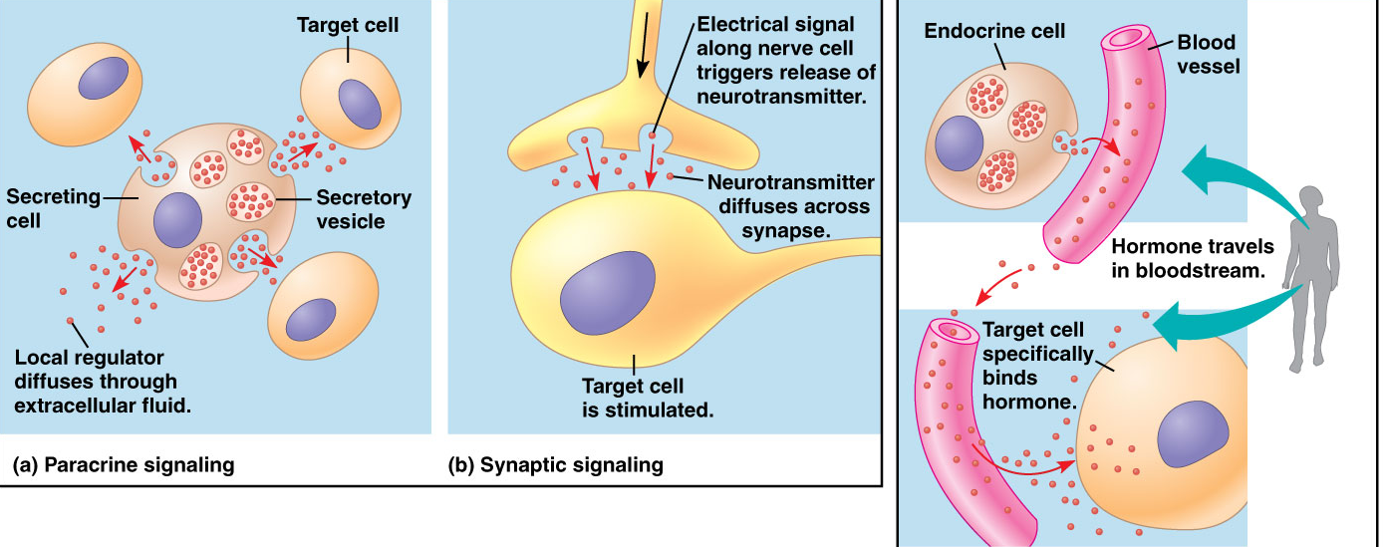

- Label each step in the process of generating a cell response:
