Unit 6 Test Prep Questions (Ch. 11 & 12)
- You have isolated DNA from three different cell types of an organism, determined the relative DNA content for each type, and plotted the results on the graph shown in Figure 13.3. Refer to the graph to answer the following questions.

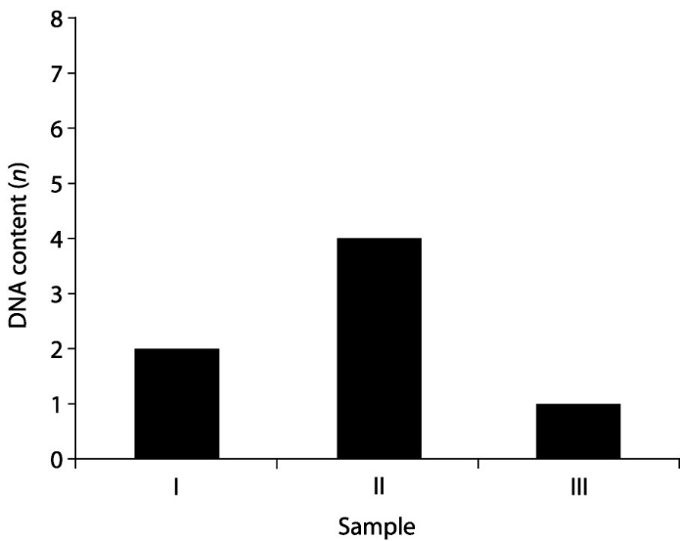

- Which sample might represent an animal cell in the G2 phase of the cell cycle?
A) I
B) II
C) III
D) both I and II
E) either II or III

- Which sample might represent a zygote?
A) I
B) II
C) III
D) either I or II
E) either II or III

Be familiar with the signaling transduction pathway.
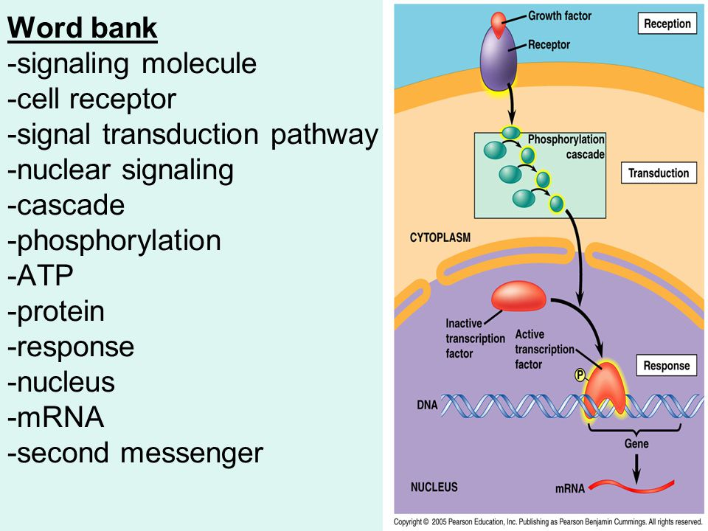

Use the diagrams to aide in your answers.
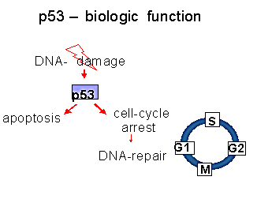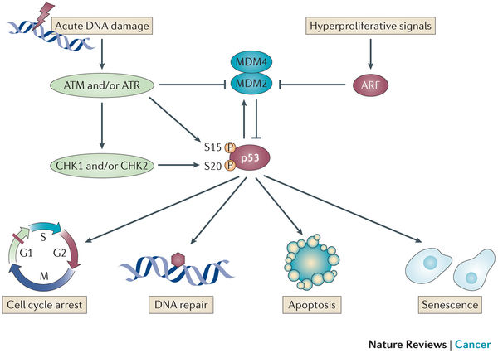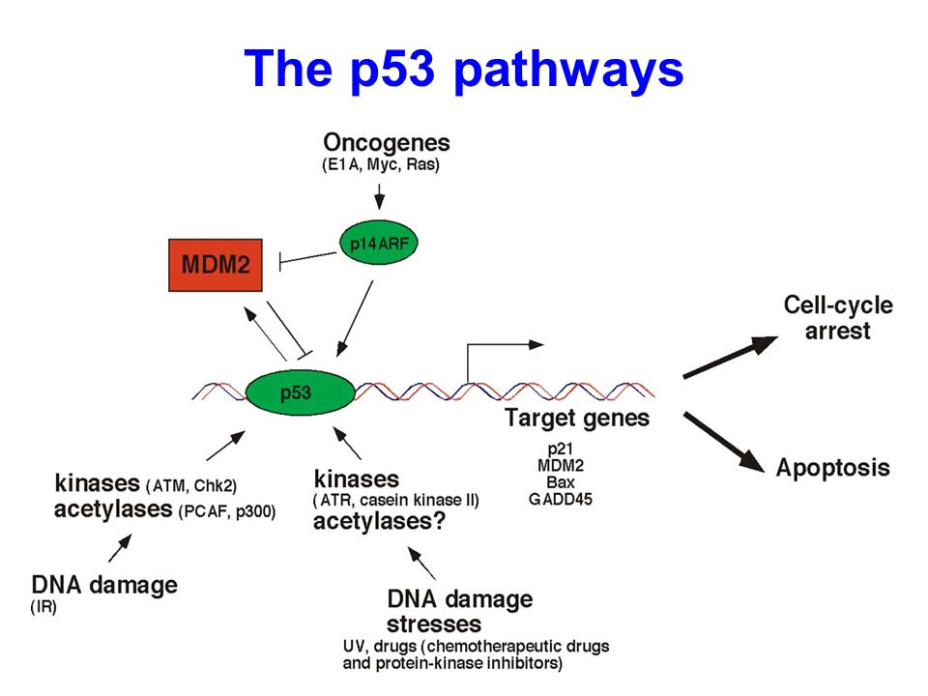
- In your own words, what is the normal functioning role of p53 in cells?

- What is the stimulus for p53 to become active?

- What is the role of protein kinases in the cell-signaling pathway?
  - Signal Reception
  - Signal Transduction
  - Cell Response

- What are the possible cell responses once p53 is activated? How does this help prevent cells from becoming cancerous?

Use the diagram to aid in your responses. Be familiar with examples such as these.
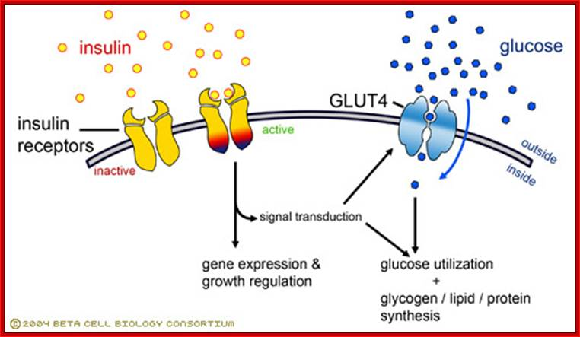
- What is the role of insulin?

- What is the signaling molecule?

- What does the active insulin receptor do?

- What is GLUT4? What does GLUT4 do?

- In a diabetic, would you expect intracellular glucose levels in a patient to be higher or lower or normal?

- In a diabetic, would you expect extracellular insulin levels in a patient to be higher or lower or normal?

- Consider diabetics. If the mutation that causes diabetes affects the insulin receptors, how might that affect the cell?

- If the mutation affects the signal transduction pathway, how would that affect the insulin receptors? How would that affect GLUT 4?

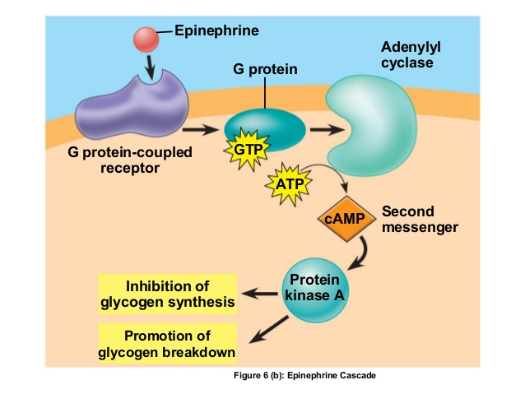
- What is the signaling molecule in this diagram?

- What type of signal receptor is illustrated?

- How is the G protein activated?

- What does the activated G protein do?

- What is adenylyl cyclase? What does it activate? How?

- What is cAMP?

- What doess cAMP activate?

- What happens to glycogen? What are the products of this reaction?

- Under what circumstances might this pathway be activated in the body’s cells?

