PHOTOSYNTHESIS (CH. 10)
LEARNING OBJECTIVE(S): | - _________________________ how photosynthesis allows organisms to ____________________ and ____________________________________________.  - ______________________ how cells capture energy from ___________________ and ______________________ it to biological molecules for ____________________ and ______________.
- Write the balanced equation for photosynthesis.

- What type of organisms perform photosynthesis? | - ___________________ and other _____________________________ are producers  - PHOTOautotrophs:  - CHEMOautotrophs:  - Heterotrophs:
- Where in the cell does photosynthesis occur? | 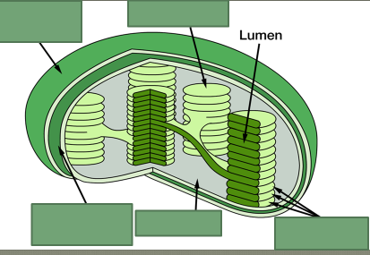  - mesophyll:  - stomata:  - chlorophyll:
- What happens to water during photosynthesis?
- What are the 2 parts of photosynthesis?  - Where do they occur?  - What are the input molecules?  - What are the ouptuts? | 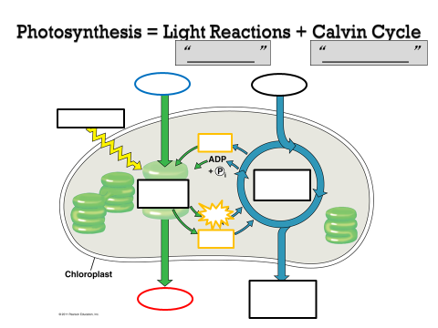
- Summarize the Light Reactions  - How does light behave? | Light Reactions: Convert _________________ energy to chemical energy of _______________ and ______________________  Nature of sunlight  - Light = Energy = ________________________________ radiation  - _________________________ wavelength (λ): __________________________ E  - Visible light - detected by human eye  - Light can be: _________________________, _________________________, or _________________________  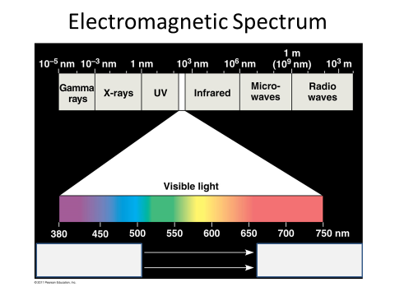  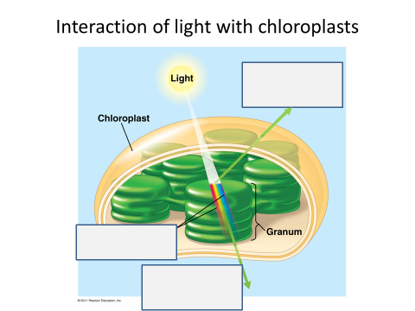
- How do different pigments respond to different wavelengths of light? | Pigments absorb different __________________________(λ) of light  ___________________________ – absorb violet-blue/red light, reflect _______________  - chlorophyll a (reflects blue-green): light reaction, converts solar to chemical E  - chlorophyll b (reflects yellow-green): conveys E to chlorophyll a  - carotenoids (reflects yellow, orange): _________________________________, broaden color spectrum for photosynthesis  - Types: xanthophyll (reflect _______________________)  - carotenes (reflect ____________________________)  - anthocyanin (reflect red, purple, blue)  ___________________ Spectrum: determines effectiveness of different wavelengths for photosynthesis
Practice Analysis of an Absorption Spectrum
- Which color/wavelength of light provides the MOST energy to plants?

- Why do most pigments have greater absorbance of shorter wavelengths of light vs. longer wavelengths?

- Why would a plant not have pigments to capture ALL wavelengths of light?

- Why do most plants appear green?

- If a plant contained mostly carotenoids, what color would you expect them to appear?

_______________________ Spectrum: plots rate of photosynthesis vs. wavelength
(absorption of chlorophylls a, b, & carotenoids combined)
- Which wavelengths of light are most effective in driving photosynthesis?

Chlorophylls & other pigments
  - embedded in ________________________________________
  - arranged in a “______________________________________”
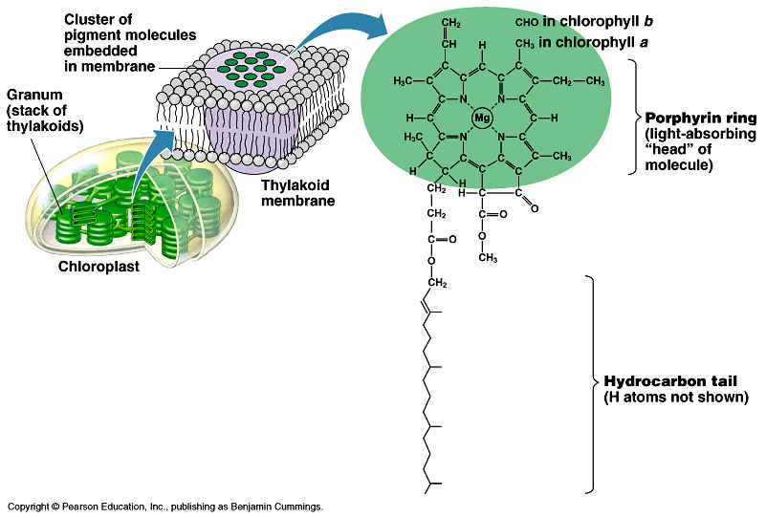
    - collection of molecules
  - structure-function relationship

QUESTIONS I STILL HAVE ARE…

SO FAR I UNDERSTAND…

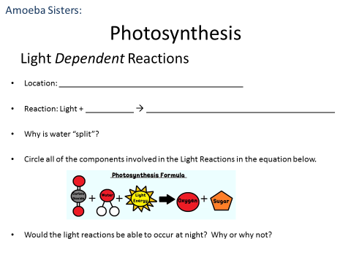
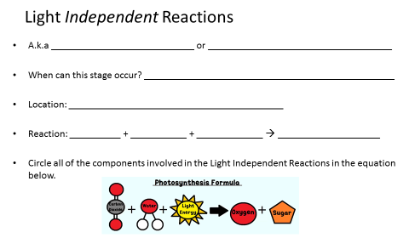
SUMMARIZE PHOTOSYNTHESIS REACTIONS:

- Overview of the Light Reactions | - Light energy ___________________________________________________ releasing ______________________________________________________  - Movement of e⁻ used to __________________________________________  - Electrons end up on NADP⁺, reducing it to ____________________________
- What is a photosystem? | 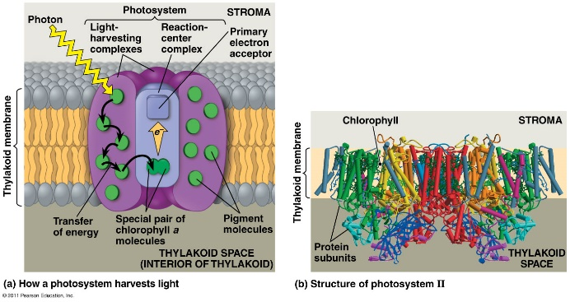  - Photosystems located in the ______________________________ act as ____________________________________ molecules  - Photosystem II – made mostly of ________________________________  - P₆₈₀ = absorbs 680nm wavelength, red light  - Photosystem I – made mostly of ________________________________  - P₇₀₀ = absorbs 700nm wavelength, red light  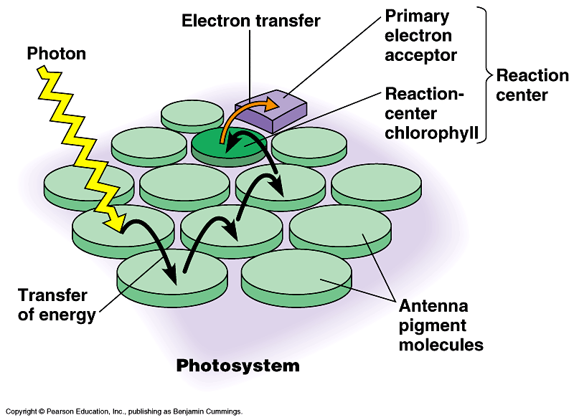  What happens in a photosystem?  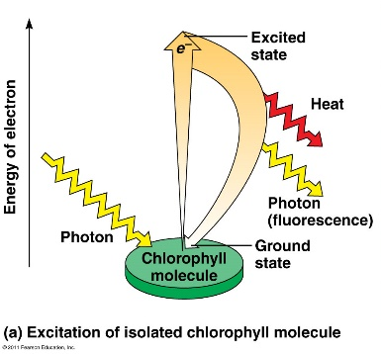  ________________________ in chlorophyll molecules are ________________________ by absorption of light
- Describe the 2 pathways for electron flow during the light reactions. | - Linear (non-cyclic) electron flow  - PS____ PS____I Calvin Cycle  - ________________ is split; ________________ released  - Cyclic (non-linear) electron flow  - PS____ only Calvin Cycle  - No water splitting  - No ______________________ or ____________ produced  - Utilized when ________ supplies are low or when _____________ is high
- Trace/outline the flow of electrons through the linear pathway. | 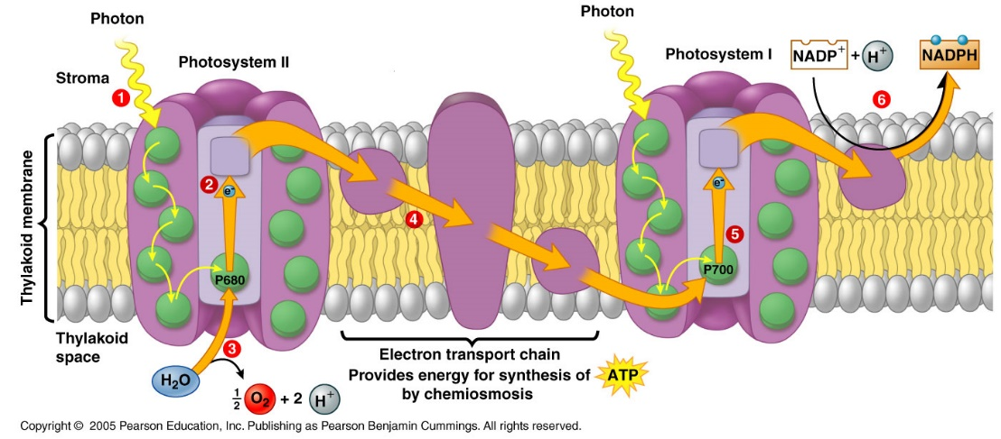  - Photons of light are absorbed by _______________________ which excites electrons (e-)  - Excited ______ passed to the primary _______________________________ in the reaction center of Photosystem _____.  - Water is ________________ (regenerates more e-) and_______ is released  - e- are passed through an _______  - e- activate primary e- acceptor of Photosystem _____; PSI also captures more photons of light here  - e- are passed through a second _____ and NADP is reduced to make ______  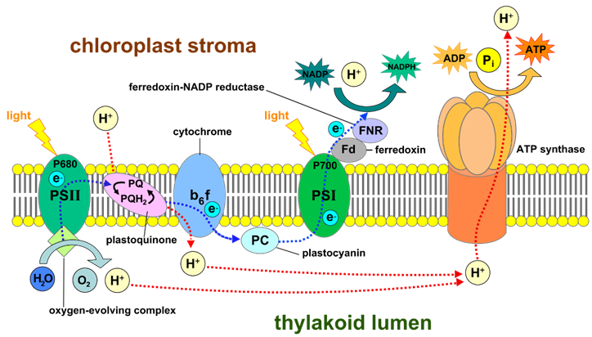  - During the e- transfers through the ETC, _____ are pumped across the thylakoid membrane to set up a proton-motive force (H+ gradient).  - As protons flow through ________________________by chemiosmosis, ______is produced.  - These steps together are called _________phosphorylation  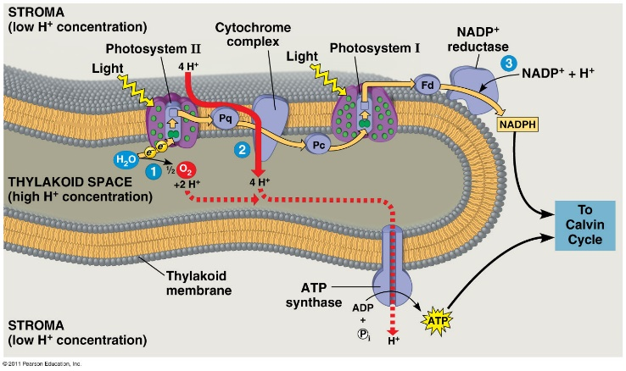  Proton motive force generated by:  - H⁺ from ________________  - H⁺ _______________ across by cytochrome protein  - Removal of H⁺ from _________ when NADP⁺ is reduced
- What is the main idea/ purpose of the light reactions?
- How is the cyclic (non-linear) flow of electrons different? | 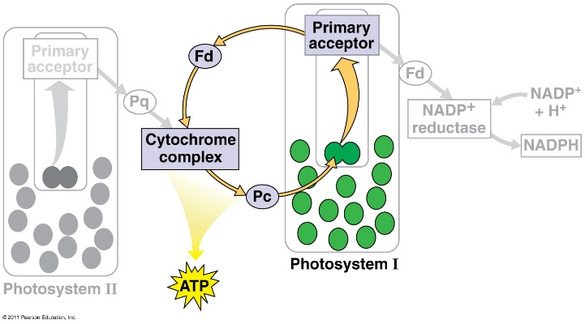  Cyclic Electron Flow:  - uses _____________________  - produces ____________ for Calvin Cycle  - does not produce ___________________________
- What similarities do we see in cellular respiration and photosynthesis? | 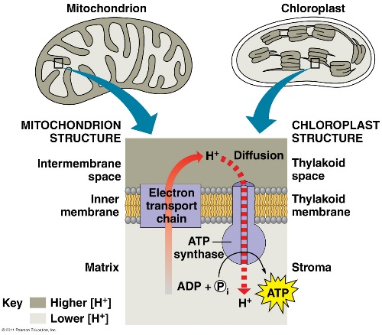  Both
Summarize the Light Reactions:

- What is the Calvin Cycle? | Calvin Cycle:  Occurs in:  Uses:  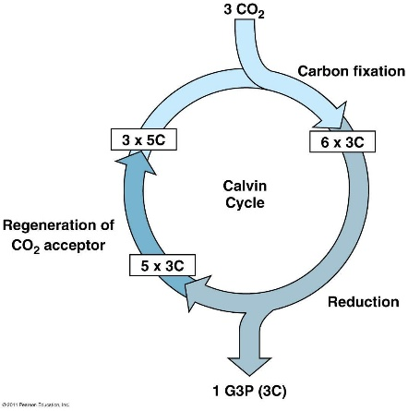  Produces:  3 Phases:  - ____________________: The enzyme called __________________ catalyzes a reaction between ________ and a 5 carbon sugar.  - ____________________: Uses 6 _______ and 6 ___________ to produce 1 net _________ (3 carbon sugar)  - ______________________________: uses 3 ATP to remake the 5 C sugar
Summarize the Calvin Cycle:

