**Endocrine System (Ch. 45)**

In conjunction with the nervous system, the endocrine system is the other main system that maintains homeostasis throughout the body. It does this by releasing chemicals called hormones, and by controlling continuous processes such as growth and development, reproduction, and metabolism.

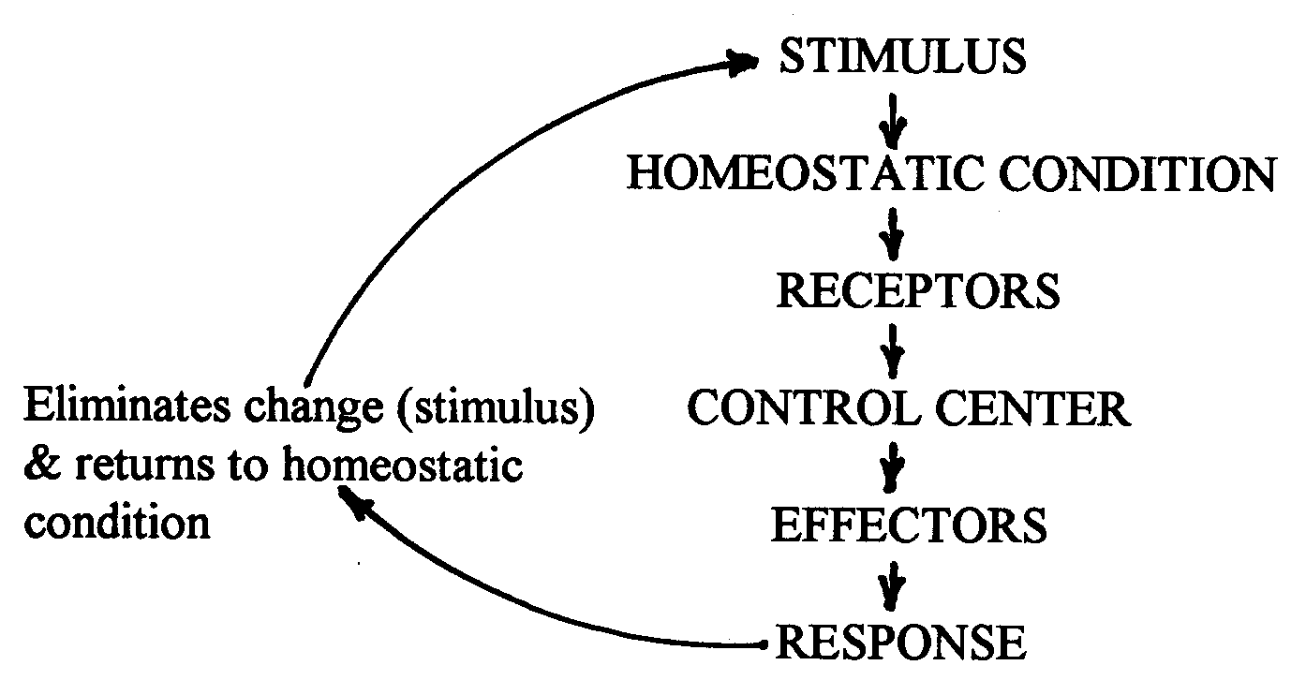

Unlike the nervous system, though, which is built for speed to respond to changes very quickly, the endocrine system works more slowly by releasing hormones into the bloodstream to be transported throughout the body to their target glands and organs.

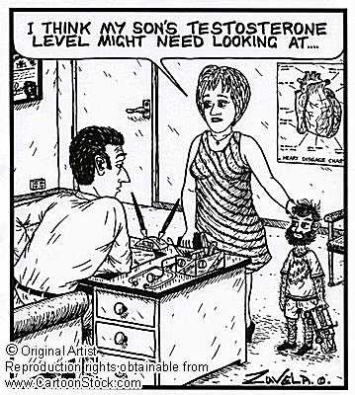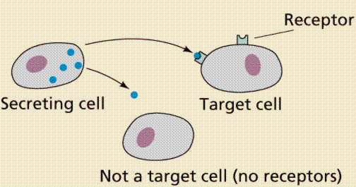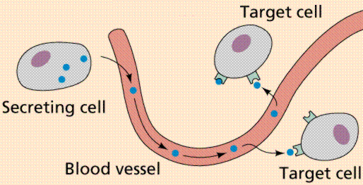

**Those Crazy Hormones!**

The power of the endocrine system lies in the amazing ability and chemistry of hormones. They can be classified as follows:

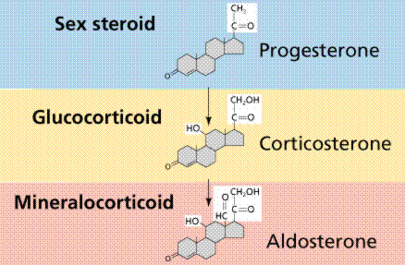

1. Peptide / Amino-Acid based (Protein-based)
2. Steroids (cholesterol (lipid)-based)
   1. sex hormones made by the gonads (ovaries and testes)
   2. those produced by the adrenal cortex

1. Prostaglandins (local; lipid-based)

**How do hormones work?**

Hormones circulate in the blood and act on specific target cells or target organs. Therefore, cells must have receptor proteins that are specific for a given hormone in order to be affected by it. These receptors may be on the outside (periphery) of the cell membrane or inside the cell.

There are two ways a hormone may act on a cell.

1. Steroid hormone action (direct messenger system)
2. Non-steroid hormone action (2nd messenger system)

Since steroid hormones are lipid-soluble (can dissolve in fats) they can pass right through the cell membrane? (Think: what is the cell membrane made of? __________________________)

1. Steroid hormone diffuses through the plasma membrane of target cell.

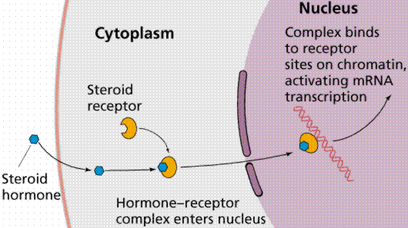

2. Steroid hormone enters the nucleus.

3. Steroid hormone binds to specific receptor protein in the nucleus.

5. Activating certain genes to transcribe messenger RNA (mRNA)

4. Binds to specific sites on the cells’ DNA.

6. mRNA exits the nucleus and is translated into a protein in the cytoplasm.

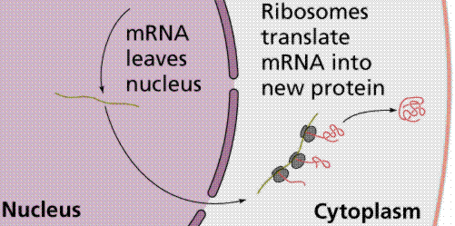

7. mRNA translated to cytoplasm and new protein is synthesized.

**2nd Messenger system** (non-steroid, water-soluble; protein hormones)

These are unable to enter the cell by diffusing through the cell membrane. (Why? _______________________) Instead, they bind to target receptor cells on the surface of the cell.

1. Hormone binds to the membrane receptor.

2. This sets off a series of reactions that activates an enzyme.

3. The enzyme catalyzes a reaction that produces a second messenger molecule called cyclic AMP (cAMP)

Step 1

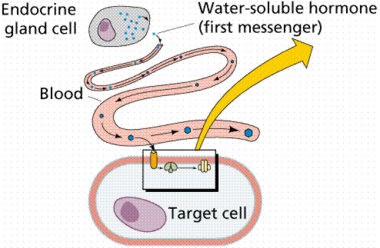

4. The 2nd messenger molecule oversees intracellular changes that cause the response of the target cell to the hormone.

Step 2

Step 3

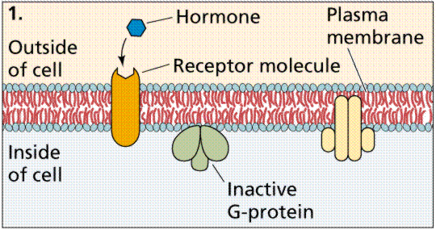

Step 4

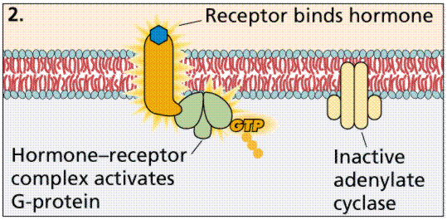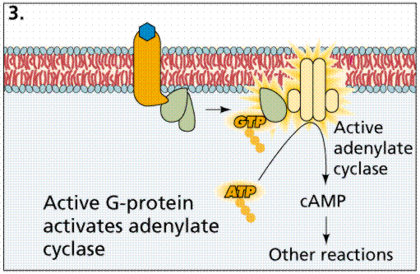

As you might guess, there are a variety of 2nd messenger molecules. Some other common ones are G proteins and calcium ions.

**How are Hormones Controlled?**

3 ways:

1. Hormonal stimuli / tropic (most common) – hormones trigger the release of other hormones
2. Humoral stimuli – changing blood levels of certain ions and nutrients causes hormones to be released
3. Neural stimuli – sometimes nerve fibers can trigger the release of hormones (Ex. sympathetic NS stimulates adrenal medulla to release NE and epinephrine)

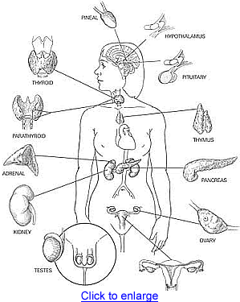

**The Major Endocrine**

What is the difference between endocrine glands and other glands of the body?

* Endocrine glands are ductless >> the hormones they secrete are released into the blood or lymph
* Exocrine glands have ducts >> release products at the body’s surface or into cavities

*Which type of gland are sweat glands?*

**Reading Questions**

1. What are hormones and how do they work? (2 pts)
2. Explain the difference between a target cell and a receptor. (2 pts)
3. How are steroid hormones different from protein-based hormones? Give several differences. (3 pts)
4. Explain why steroid hormones can use the direct messenger system while non-steroid (Protein-based) hormones must rely on the 2nd messenger system. (4 pts)

**Multiple-Choice Questions – You may need to refer to Ch. 45**

1. **All hormones**

A) are produced by endocrine glands.

B) are lipid-soluble molecules.

C) are carried to target cells in the blood.

D) are protein molecules.

E) elicit the same biological response from all of their target cells.

1. **In a positive-feedback system where hormone A alters the amount of protein X**

A) an increase in A always produces an increase in X.

B) an increase in X always produces a decrease in A.

C) a decrease in A always produces an increase in X.

D) a decrease in X always causes a decrease in A.

E) it is impossible to predict how A and X affect each other.

1. **Different body cells can respond differently to the same peptide hormones because**

A) different target cells have different sets of genes.

B) each cell converts that hormone to a different metabolite.

C) a target cell's response is determined by the components of its signal transduction pathways.

D) the circulatory system regulates responses to hormones by routing the hormones to specific targets.

E) the hormone is chemically altered in different ways as it travels through the circulatory system.

1. **When a steroid hormone and a peptide hormone exert similar effects on a population of target cells, then**

A) the steroid and peptide hormones must use the same biochemical mechanisms.

B) the steroid and peptide hormones must bind to the same receptor protein.

C) the steroid hormones affect the synthesis of effector proteins, whereas peptide hormones activate effector proteins already present in the cell.

D) the steroid hormones affect the activity of certain proteins within the cell, whereas peptide hormones directly affect the processing of mRNA.

E) the steroid hormones affect only the release of proteins from the target cell, whereas peptide hormones affect only the synthesis of proteins that remain in the target cell.

1. **For hormones that homeostatically regulate cellular functions,**

A) negative feedback typically regulates hormone secretion.

B) the circulating level of a hormone is held constant through a series of positive feedback loops.

C) both lipid-soluble hormones and water-soluble hormones bind to intracellular protein receptors.

D) endocrine organs release their contents into the bloodstream via specialized ducts.

E) it is impossible to also have neural regulation of that system.

1. **During mammalian labor and delivery, the contraction of uterine muscles is enhanced by oxytocin. This is an example of**

A) a negative feedback system.

B) a hormone that acts in an antagonistic way with another hormone.

C) a hormone that is involved in a positive feedback loop.

D) signal transduction immediately changing gene expression in its target cells.

E) the key role of the anterior pituitary gland in regulating uterine contraction.

1. **During short-term starvation, most available fuel molecules are catabolized to provide energy for metabolism rather than being used as building blocks for growth and repair, a trade-off that is hormonally regulated by**

A) acetylcholine.

B) glucagon.

C) oxytocin.

D) antidiuretic hormone.

E) insulin.

1. **When the beta cells of the pancreas release insulin into the blood,**

A) the blood glucose levels rise to a set point and stimulate glucagon release.

B) the skeletal muscles and the adipose cells take up glucose at a faster rate.

C) the liver catabolizes glycogen.

D) the alpha cells of the pancreas release glucose into the blood.

E) the kidneys begin gluconeogenesis.

1. **Steroid and peptide hormones typically have in common**

A) the building blocks from which they are synthesized.

B) their solubility in cell membranes.

C) their requirement for travel through the bloodstream.

D) the location of their receptors.

E) their reliance on signal transduction in the cell.

**Practice:**

Use the chart attached to answer the following questions.

* 1. How are steroid hormones different from the other protein-based hormones?
  2. What type of signaling transduction pathway (activation pathway) would they use and why?
  3. During puberty what hormones would be most active? Why?
  4. What be the effect of these hormones in boys and girls?
  5. When GH is activated, it causes amino acids to be built into proteins and causes fat to be broken down. At what stage in life is the activity of this hormone most obvious? How do you know?
  6. What is a possible consequence of malnutrition?
  7. What are some possible consequences (general) of a deficit of GH? of an excess? (p. 285)
  8. What glands would be most active in a pregnant woman about to give birth?
  9. What hormones would be present?
  10. Which glands and hormones would become active as soon as the baby was born?

1. Which gland do you think is the most important and why?**Details of the Glands**

|  |  |  |  |  |
| --- | --- | --- | --- | --- |
| **Gland** | **Hormone(s)** | **Chemical Class** | **Action** | **Regulated by:** |
| Pineal Gland | melatonin | amine(protein) | rhythmic activities | light/dark cycles |
| Hypothalamus | releasing and inhibiting hormones that regulate the pituitary | protein | regulate the pituitary | nervous system |
| Pituitary gland:   * posterior lobe (releases hormones made by the hypothal) * anterior lobe | oxytocin  Antidiuretic hormone (ADH)  Growth Hormone (GH)  Prolactin (PRL)  Follicle-stimulating hormone (FSH)  Luteinizing hormone (LH)  Thyroid-stimulating hormone (TSH)  Adrenocorticotropic hormone (ACTH) | protein  protein  protein  protein  protein  protein  protein  protein | stimulate uterine contractions and milk “letdown” reflex  causes kidneys to retain (hold on to) water  stimulate growth (of bone and muscle) and metabolism  stimulate milk production  stimulate production of ova and sperm  stimulates ovaries and testes  stimulates thyroid gland  stimulates adrenal cortex | nervous system  hypothalamus  hypothal. hormones  hypo.  hypo.  hypo.  hypothalamus; Thyroxine in blood;  hypo; glucocorticoids |
| Thyroid Gland | Thyroxine (T4) and tri-iodothyronine (T#)  Calcitonin | protein  protein | stimulates metabolism  reduces blood calcium level | TSH  calcium level in blood |
| Parathyroid glands | Parathyroid hormone (PTH) | protein | raises blood calcium level | calcium level in blood |
| Thymus | Thymosin | protein | programs T cells (of immune system) | not known |
| Adrenal glands   * Adrenal medulla * Adrenal cortex | epinephrine and norepinephrine  Glucocorticoids (ex: cortisone and cortisol)  Mineralocorticoids (ex: rennin to target kidneys) | proteins  steroids  steroids | inc. blood glucose; increase metabolic rate; constrict certain blood vessels  increase blood glucose  promotes reabsorption of Na+ and excretion of K+ in kidneys | sympathetic NS  ACTH  changes in blood volume or blood pressure; K+ or Na+ levels in blood |
| Pancreas | Insulin  Glucagon | protein  protein | reduces blood glucose levels  raises blood glucose | glucose level in blood  glucose level in blood |
| Gonads   * Testes * Ovaries | Androgens (ex: testosterone)  Estrogens  Progesterone | steroids  steroids  steroids | support sperm formation; development and maintenance of male secondary sex characteristics  stimulate uterine lining growth; development and maintenance of female secondary sex characteristics  promotes growth of uterine lining | FSH and LH  FSH and LH  FSH and LH |

Review: Can you label the following endocrine glands?

Endocrine Bank

Pineal gland

Hypothalamus

Pituitary gland

Thyroid

Parathyroid glands

Thymus gland

Pancreas

Adrenal gland

1. Insulin
2. Melatonin
3. Glucagon
4. ADH
5. PTH
6. ACTH
7. GH
8. T3 and T4
9. Calcitonin
10. estrogen
11. progesterone
12. testosterone
13. LH
14. FSH
15. Prolactin
16. Oxytocin
17. Renin
18. Cortisol
19. norepinephrine
20. epinephrine

**Directions**: Match each endocrine gland/organ with the hormones it secretes. Each gland may have more than one hormone.

1. ______ Adrenal cortex
2. ______ Adrenal medulla
3. ______ Testes
4. ______ Hypothalamus
5. ______ Pancreas
6. ______ Pineal gland
7. ______ Pituitary gland
8. ______ Thymus
9. ______ Thyroid
10. ______ Parathyroid
11. ______ Ovaries

What endocrine organs are not pictured here?

* ________________
* ________________

