AP Review – DNA REPLICATION

Fill in what you remember!
EUKARYOTES

PROKARYOTES

5b.
________________________ seals Okazaki fragments together
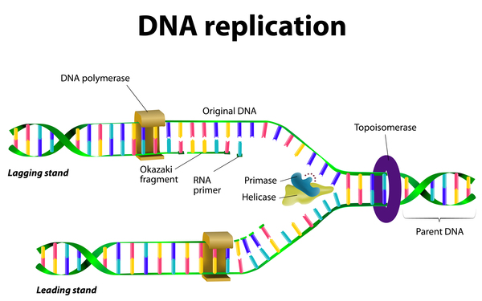
5a.
_______ _____________________ replaces RNA primers with DNA on lagging strand
2.
_________________ bubble formed; held open and stabilized by ssb proteins
3a.
_________________ lays down RNA primer to start replication
1.
_______________ unwinds DNA at origins of replication
4.
_____________________ strand grows in 3’ 5’ direction by the addition of _________________ fragments
3b.
_________________________ add complementary bases to leading strand (added to 3” end of nucleotide)
New DNA made in __________ direction

GOTTA KNOW:
HELICASE DNA POLYMERASE (I, III) LEADING vs LAGGING STRAND
PRIMASE REPLICATION OCCURS 5’ 3’
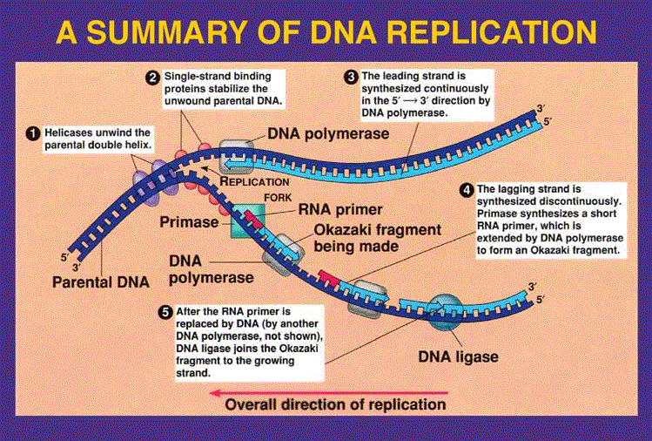
PROTEIN SYNTHESIS
The Central Dogma explains the direction/flow of genetic information:
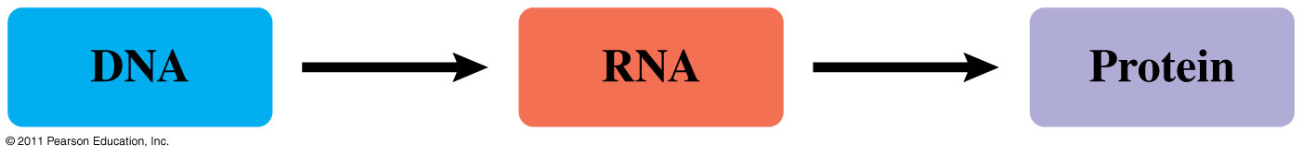
T________________________
________ ________
T________________________
________ ________

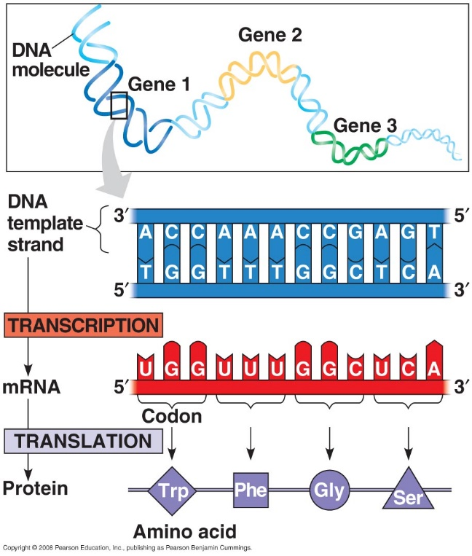
TRANSCRIPTION

Template strand -
Complementary Strand -
Codon -
RNA POLYMERASE: ______________________ DNA strands and ________________________________
- mRNA elongates/grows in _____________ direction
- Attaches to _______________________ (start of gene) and stops at _______________ (end of gene)

How is protein synthesis DIFFERENT in PROKARYOTES vs EUKARYOTES?
Fill in what you remember about TRANSCRIPTION! Add as we go.
PROKARYOTES

EUKARYOTES

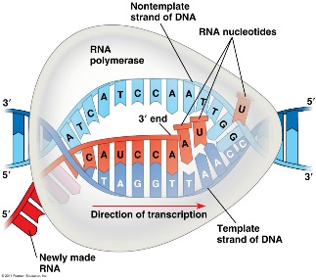
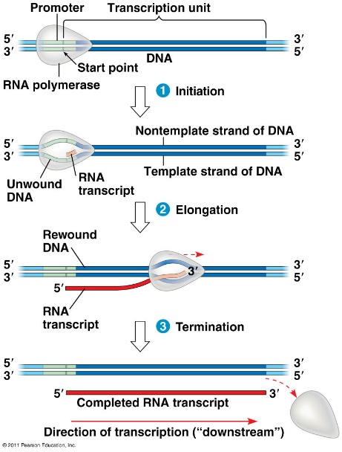
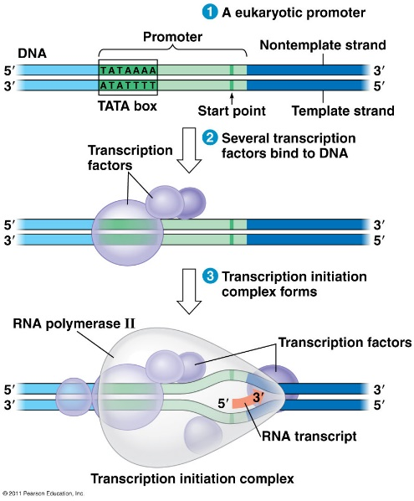
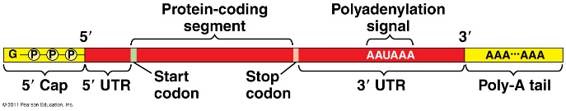
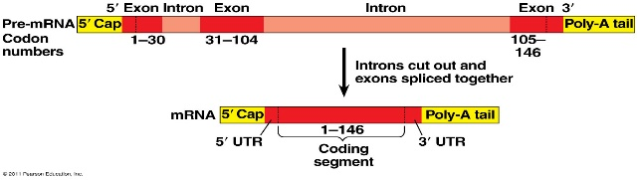
KEY VOCAB:
Promotor
TATA box
Transcription factors
RNA polymerase
Pre-mRNA vs mature mRNA
5’ cap
Poly-A tail
RNA processessing
Splicing
Spliceosomes
Introns
Exons

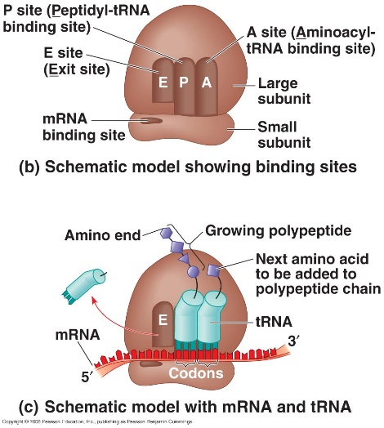
TRANSLATION

Occurs at __________________________
Active sites:
- ______________: holds AA to be added
- ______________: holds growing polypeptide chain
- ______________: exit site for tRNA

Can more than 1 ribosome translate a single mRNA?

How does protein production differ between…
- (Free) Cytoplasmic Ribosomes

- (Bound) Ribosomes attached to ER

What cell components make up the endomembrane system?

GENE EXPRESSION IN PROKARYOTES
- Bacteria respond to environmental changes by regulating ______________________________
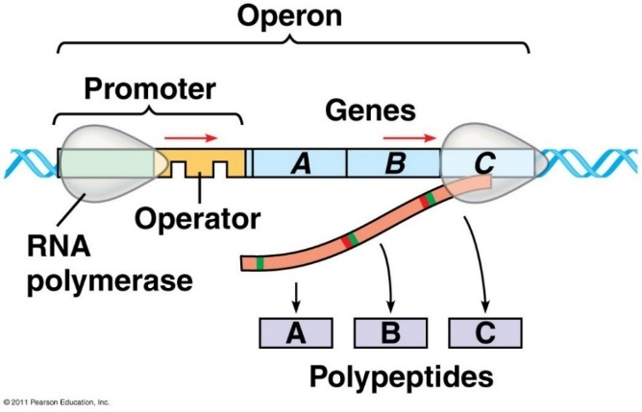
- Genes clustered into ______________________ that can be ______________________ (turned on) or _______________________________________ (turned off) 3 parts:
- _______________________________ – where RNA polymerase attaches to begin transcription
- _______________________________ – “on/off”, controls access of RNA polymerase to the mRNA
- _______________________________ – code for related enzymes in a pathway

- Regulatory genes: produces _______________________ protein that binds to operator to block RNA polymerase and turn operon off

- Example of a Repressible Operon:

- Example of an Inducible Operon:

GENE EXPRESSION IN EUKARYOTES
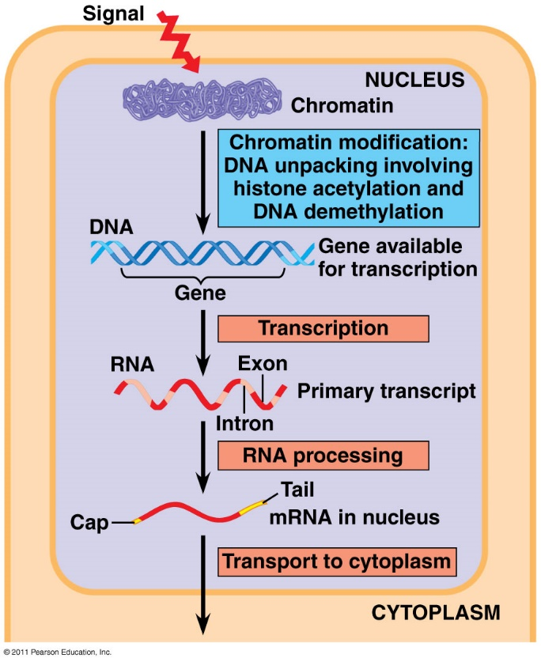

In the nucleus, there is chromatin regulation:
- DNA Methylation:
- methyl groups added to DNA
- keeps DNA/chromosome _______________________, unaccusable
- ________________________ transcription
- (turns genes _________)

- Histone Acetylation:
- acetyl groups added to histones
- chromatin ______________________ – easily accessed
- ________________________ transcription
- (turns genes ________)
In the nucleus, transcription is regulated by:
- _____________________________________________ that bind to control regions of the DNA; 2 kinds:
  - Activators:
  - Repressors:
- Transcription regulation by micro RNAs and small interfering RNAs
- RNA Processing:

In the cytoplasm, translation is regulated by:

