CH. 14: MENDEL AND THE GENE IDEA

- Summarize Mendel’s Law of Segregation.

- Summarize Mendel’s Law of Independent Assortment.

- What is a test cross?

  - Brown fur is dominant to white fur in pups. The owner of a brown haired dog wants to know its genotype. What should he do?

  - Suppose the owner mated his brown haired dog with a white haired dog and 3 of the 6 pups had white fur. What must be the genotype of the brown dog?

- What is a monohybrid cross?

- What is a dihybrid cross?

- Summarize the Rules of Multiplication and Rule of Addition for probability by completing each statement.
  - If you want to know the chances of event 1 and event 2, then ____________________ them.
  - If you want to know the chances of event 1 or event 2, then _________________ them.

- How is incomplete dominance different from codominance?

- How is multiple alleles different from polygenic inheritance?

- How is pleiotropy different from polygenic inheritance?

- Explain epistasis.

- Match each genetic disease with its description.
TAY SACHS SICKLE CELL HUNTINGTONS CYSTIC FIBROSIS
  - _________________________________ an autosomal dominant disease that causes the deterioration of the nervous system, but doesn’t present until middle age
  - _________________________________ the presence of a faulty enzyme leads to buildup of lipids in the brain causing seizures, loss of brain function, and early death
  - _________________________________ results in a buildup thick sticky mucous due to cells being unable to transport chloride ions across the membrane.
  - _________________________________ Crescent shaped red blood cells that cause pain and organ damage because the hemoglobin protein (and gene) are mutated.

CH. 15: THE CHROMOSOMAL BASIS OF INHERITANCE
- Draw a diagram that illustrates the chromosomal theory of inheritance.

- What was the contribution of Thomas Hunt Morgan to our understanding of genetics? What did he study?

- How are X-linked and Y-linked genes different? What do they have in common?

- Why do we not use the terms homozygous and heterozygous for X-liked traits in males?

- Identify each sex-linked disorder with its description.
  - ______________________________________: X-linked disorder whereby blood does not clot normally; missing blood clotting proteins
  - ______________________________________: X-linked disorder characterized by muscle weakening and loss of coordination; early death

- X-inactivation regulates [gene / chromosome] dosage in [males / females]. During [embryo / gamete] development one X chromosome is randomly inactivated by [polymerization / methylation / mutation]. This results in males and females having the same number of expressed genes with loci on the X chromosome. The inactive chromosome condenses into a ________ body.

- Why do linked genes tend to be inherited together?

- Define genetic recombination.

- What are parental types? How are these different from recombinants?
- ___________________________________ can explain why some linked genes get separated during meiosis. The _____________________ apart 2 genes are on the same chromosome, the ___________________ the probability that crossing over will occur between them.

- What is a linkage map?

- What is non-disjunction and when does it occur?

- Fill in the diagram to show a diploid cell (2n = 6) that undergoes a nondisjunction in meiosis 1. Then draw the same diploid cell as it experiences a non-disjunction in meiosis 2. How do the chromosome numbers of the gametes compare?
NON-DISJUNCTION MEIOSIS 1 NON-DISJUNCTION MEIOSIS 2
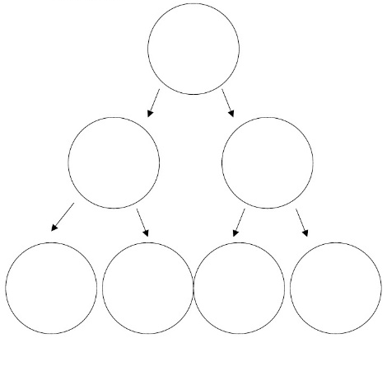

- Use the following terms to complete each sentence.
ANEUPLOIDY POLYPLOIDY TRISOMIC MONOSOMIC
  - If a human diploid cell has 47 chromosomes, then it is _____________________ for one chromosome.
  - If a human diploid cell has 45 chromosomes, then it is _____________________ for one chromosome.
  - A person with Turners Syndrome or Klinefelters Syndrome both have cells with incorrect chromosome numbers so they are both ____________________________.
  - A plant cell that has a chromosome number of 3n or 4n is an example of ________________________.

- Label each diagram with the correct type of chromosomal mutation.

- How are mitochondrial and plastid DNA inherited?

Use the Pearson Education AP Test Prep Series for AP Biology study book to answer the following multiple choice questions. Page 114-116 (1-3, 5-11, 13, 21-22)
- ______
- ______
- ______
- ______
- ______
- ______
- ______
- ______

- ______

- ______
- ______

- ______
- ______

and page 117 (1-3)

and page 118 (5-6)
- ______
- ______

