Ch. 4: Carbon and the Molecular Diversity of Life
- Learning Objective: Describe the composition of macromolecules required by living organisms.
- Why study carbon?

- What are ORGANIC compounds?

- Why is Carbon (C) so diverse? | 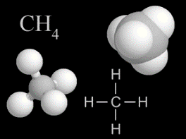  - It has ____ valence electrons  - I can form up to ___ _________________ bond  - Can form ________________, _________________, or triple bonds  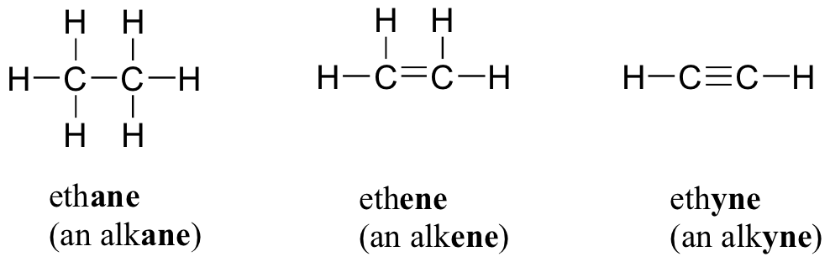  - Can form _______________ macromolecules such as:  - Carbon compounds can be ___________, rings, or _____________  - Forms _______________________: molecules with the same molecular formula but different arrangement of ______________  - Different structure different _____________________
- What are different types of ISOMERS? | Structural Isomer |  | Cis-Trans Isomer |  | Sterioisomer
 | Varies in  _______________ arrangement |  | Differ in ______________ arrangement |  | ____________  images of molecules
 | 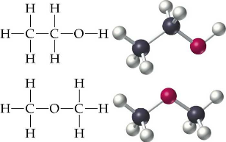 |  | 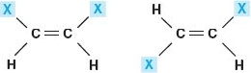 |  | 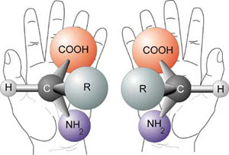
- What are FUNCTIONAL GROUPS and why are they important? | - Parts of ___________________ molecules that are involved in ______________________________________  - Affect _________________________  Ex:
- What are formulas and properties of the most common organic functional groups? | Functional Group | Details / Examples |  | Functional Properties
 | Hydroxyl
 | Carbonyl
 | Carboxyl
 | Amino
 | Sulfhydryl
 | Phosphate
 | Methyl
- What are MACROMOLECULES? List the “BIG 4”
- What are POLYMERS?
- How are polymers BUILT? | - _________________________: joins monomers by “taking” __________ out  - requires ____________________ & _______________________  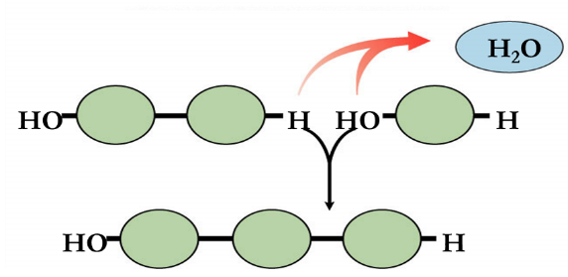
- How is a polymer BROKEN DOWN | - _________________________: add ___________ to break down polymers  - requires __________________ & ____________________ energy  