**Ch. 43: The Immune System**

**What Do You Need to Know?**

* Several elements of an **__________ immune response**
* The differences between **____** and **____ cells** relative to their activation and actions.
* How **________________** are recognized by immune system cells
* The differences in **__________** and **___________________________ immunity**
* Why **__________** cells are central to immune responses

**Types of Immunity**

|  |  |
| --- | --- |
| **Innate Immunity** | **Adaptive Immunity**  **(*Acquired*)** |
| * **________________** * All _________& _______________ | * _________________ * Only in ___________ * Involves _______________________ |

**Do plants have immune defenses?**

* ______________________ responses
* Receptors recognize __________________ molecules and trigger _________________responses
  + Thicken cell wall, produce antimicrobial compounds, cell death
* 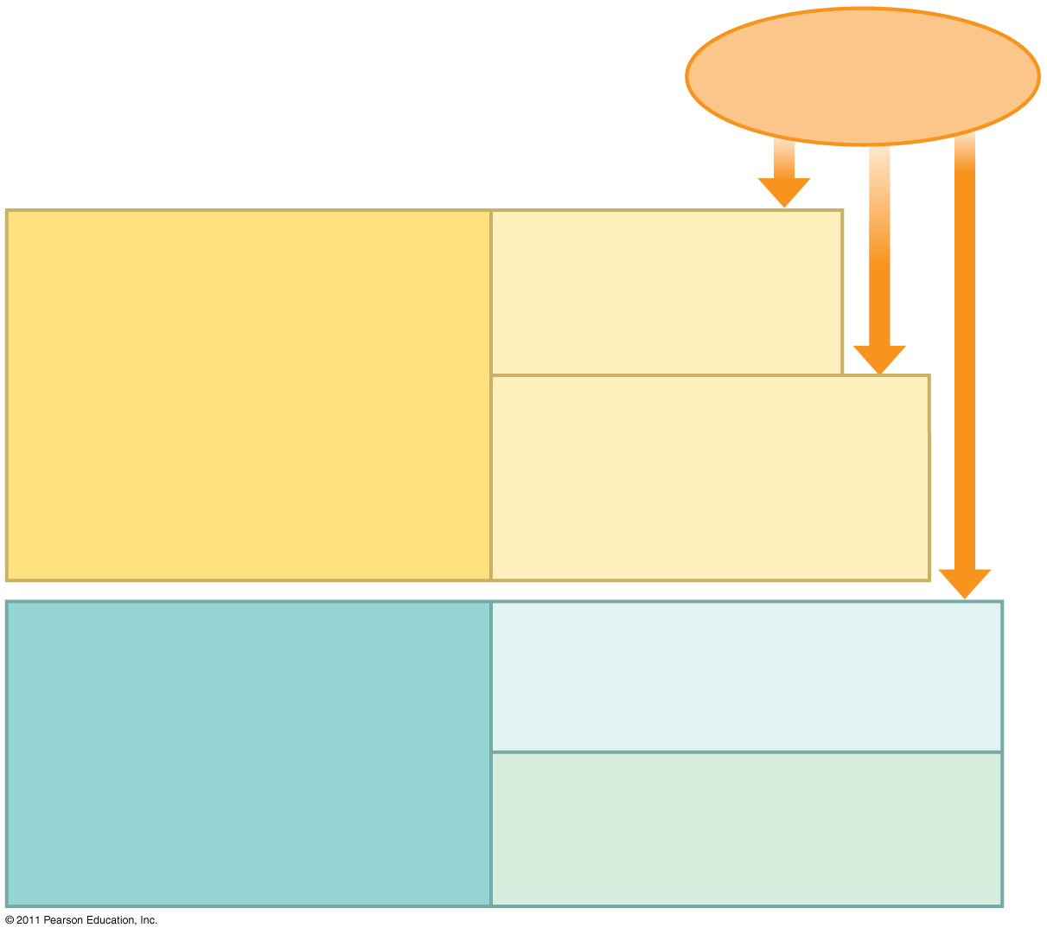Localize effects

**Types of Immunity continued**

**Barrier Defenses:**

* ___________________________
* Mucous ____________________
* Secretions
* **Recognition of traits shared by ___________ranges of pathogens, using a __________ ___________ of receptors**
* **_____________response**

**Cell Mediated Response:**

* _________________ cells defend against infection in body cells

**Humoral Response:**

* ______________________ defend against infection in body fluids

**__________________ defenses**

* Phagocytic cells
* Natural Killer cells
* Antimicrobial ____________________
* _______________________ response
* **Recognition of traits ___________to particular pathogens, using a vast  
  array of receptors**
* **__________________response**

**What are PHAGOCYTES? (phagocytic cells)?**

**How are phagocytes involved in the inflammatory response?**

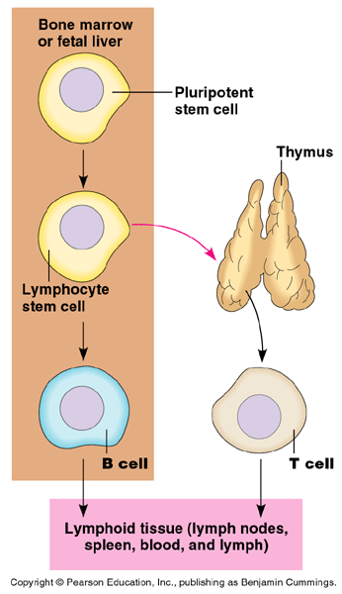**What is the Adaptive Response? (adaptive immunity)**

**Lymphocytes** -

* ____________ mature in *_____________*
  + helper T, cytotoxic T
* ____________: stay and mature in *_____________*
  + plasma cells 🡪 _____________________

**Antigen**:

**Antibody**:

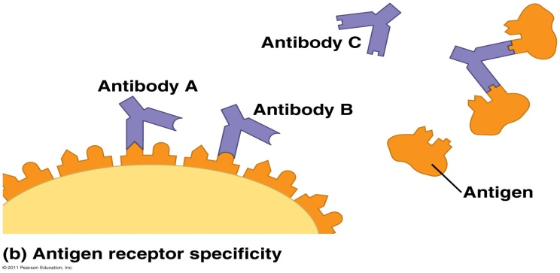

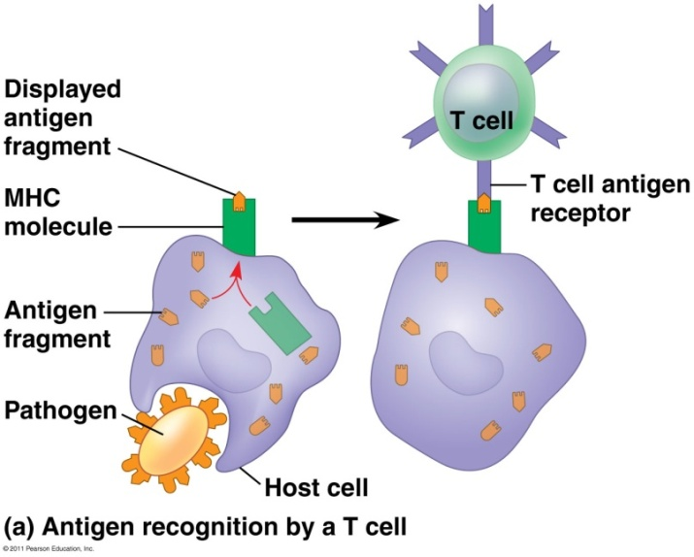

**What is an MHC? _____________________________________**

* _________________________ displayed on ____________________________________
* Responsible for tissue/organ _______________________ (“self” vs. “non-self”)
* ______________________________________ bind to MHC molecule in adaptive response
* Class I: _________________________________________ (except RBCs)
* Class II: ___________________________________________________; “non-self”

**MAIN IDEAS / KEY POINTS:**

**Read the Following:**

***The Origin of Self Tolerance***

Antigen receptors are generated by random rearrangement of DNA. As lymphocytes mature in bone marrow or the thymus, they are tested for self-reactivity. Some B and T cells with receptors specific for the body’s own molecules are destroyed by apoptosis, or programmed cell death. The remainder are rendered nonfunctional.

**READING: Concept 43.3: Adaptive immunity defends against infection of body fluids and body cells**

Acquired immunity has two branches: the **humoral immune response** and the **cell-mediated immune response.** In the humoral immune response antibodies help neutralize or eliminate toxins and pathogens in the blood and lymph. In the cell-mediated immune response specialized T cells destroy affected host cells.

***Proliferation of B Cells and T Cells***

In the body there are few **lymphocytes** with **antigen receptors** for any particular **epitope**. In the lymph nodes, an **antigen** is exposed to a steady stream of lymphocytes until a match is made. This binding of a mature lymphocyte to an antigen initiates events that activate the lymphocyte. Once activated, a B or T cell undergoes multiple cell divisions. This proliferation of lymphocytes is called **clonal selection.** Two types of clones are produced: short-lived activated **effector cells** *(plasma cells)* that act immediately against the antigen and long-lived **memory cells** that can give rise to effector cells if the same antigen is encountered again.

***Helper T Cells: A Response to Nearly All Antigens***

A type of T cell called a **helper t cell** triggers both the humoral and cell-mediated immune responses. Signals from helper T cells initiate production of antibodies that neutralize pathogens and activate T cells that kill infected cells. **Antigen-presenting cells** have class I and class II MHC molecules on their surfaces. Class II MHC molecules are the basis upon which antigen-presenting cells are recognized. Antigen receptors on the surface of helper T cells bind to the antigen and the class II MHC molecule; then signals are exchanged between the two cells. The helper T cell is activated, proliferates, and forms a clone of helper T cells, which then activate the appropriate B cells.

***Cytotoxic T Cells: A Response to Infected Cells***

**Cytotoxic T cells** are the effector cells in the cell-mediated immune response. Cytotoxic T cells recognize fragments of foreign proteins produced by infected cells and possess an accessory protein that binds to class I MHC molecules. The activated cytotoxic T cell secretes proteins that disrupt the membranes of target cells and trigger apoptosis.

**Questions:**

1. What is/are the difference(s) between innate vs. adaptive (acquired) immunity?
2. What is an epitope? (either infer or look it up).
3. What does the term “neutralize” most likely mean from paragraph 3?
4. What is mean by the term “proliferate” within the text?
5. Contrast the functions of B cells and T cells.
6. How are antigens recognized by immune system cells?
7. What are memory cells?



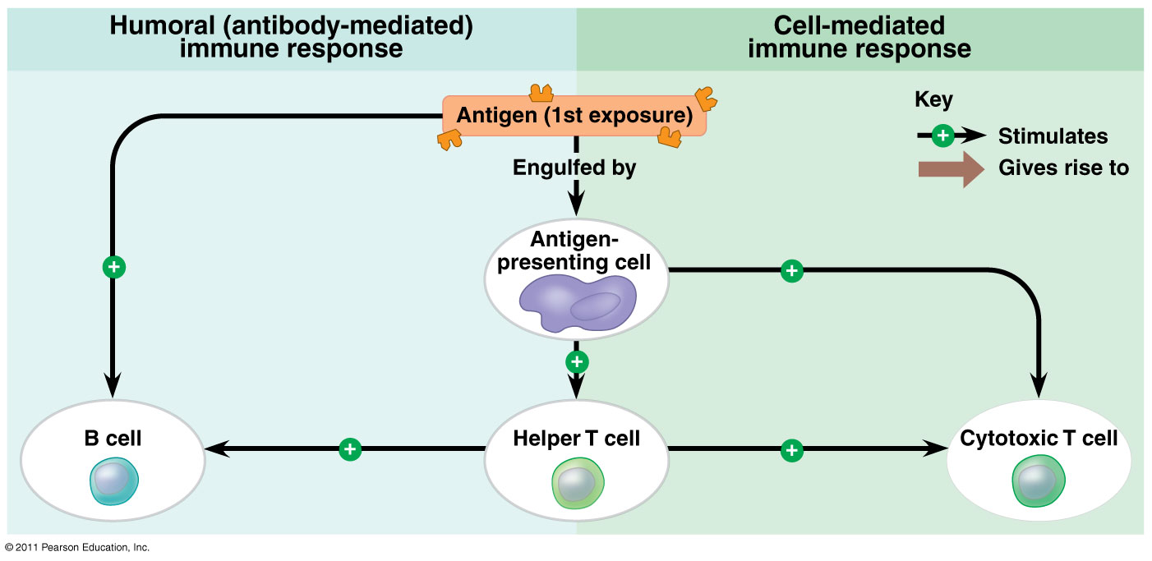

**DISCUSS & RESPOND:**

1. During the first exposure to the antigen, what cells are activated?
2. How would the **humoral immune response** be affected if the the Helper T cells were not working or disabled?
3. How would the **cell-mediated immune response** be affected if the the Helper T cells were not working or disabled?

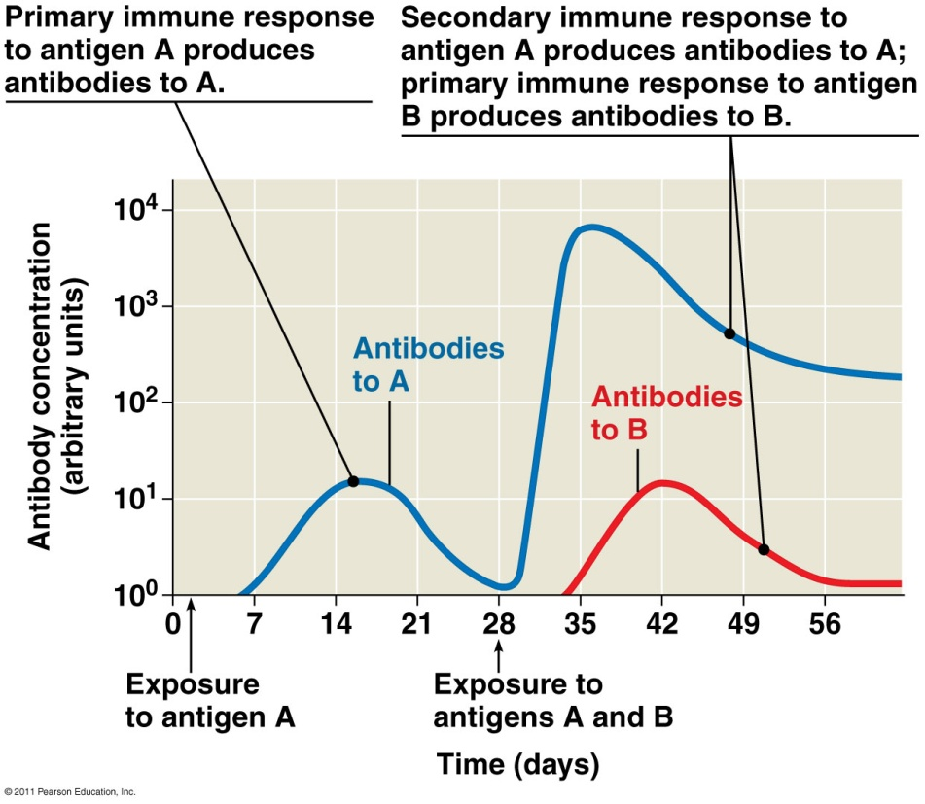**Immunological Memory**

* Primary immune response:
* **Memory cells:**

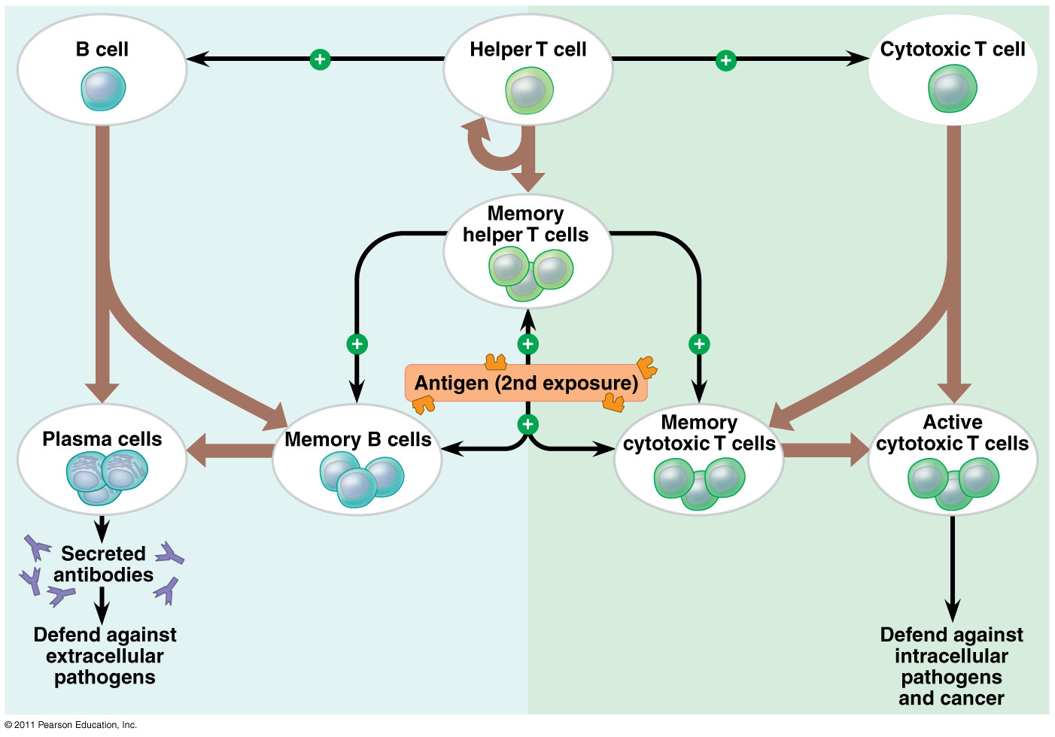

**DISCUSS & RESPOND:**

1. What is the role of the Helper T cells during the 2nd antigen exposure?
2. What “new” type of cells are recruited?

**Label the diagram below in the cell-mediated immune response.**

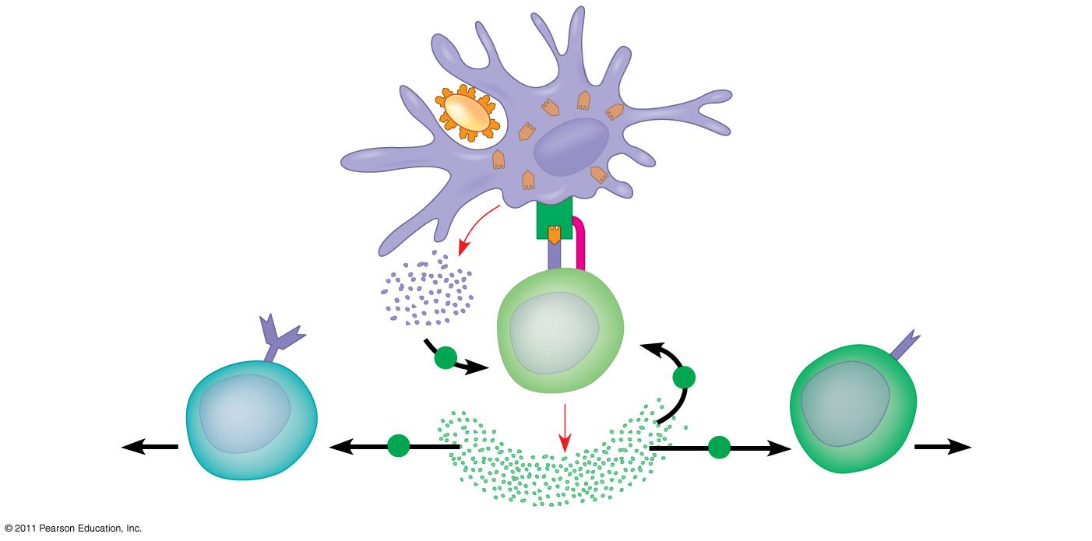

***B Cells and Antibodies: A Response to Extracellular Pathogens***

The humoral response is characterized by secretion of **antibodies** by B cells. Activation of the humoral immune response involves B cells and helper T cells as well as proteins on the surface of pathogens. In response to **cytokines** from helper T cells and an antigen, a B cell proliferates and differentiates into memory B cells and antibody secreting effector cells called **plasma cells.**

1. What is the main component of the humoral response?
2. What are cytokines?

**Label the diagram below in the humoral immune response.**

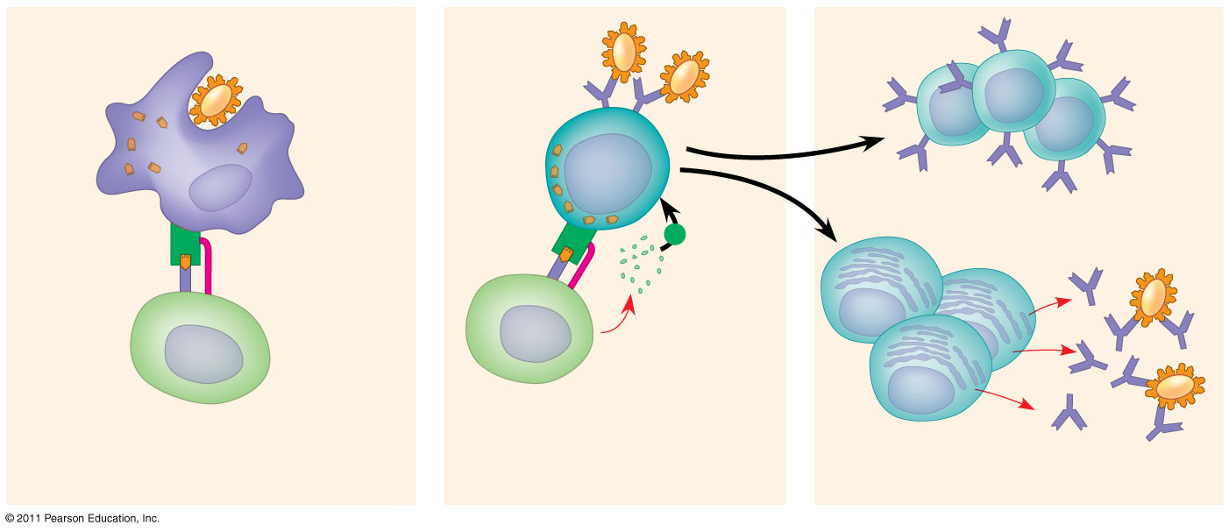

**What are the roles of ANTIBODIES?**

1. In _______________________, antibodies bind to _______________ surface proteins preventing infection of a host cell
2. Antibodies may also bind to ___________ in body fluids and prevent them from entering body cells
3. In **______________________________**, antibodies bind to antigens on ____________________ creating a target for ________________________ or neutrophils, triggering _____________________
4. Antigen-antibody complexes may bind to a **_________________________________________** —which triggers a cascade of complement protein activation
5. Ultimately a membrane attack complex forms a ________________ in the membrane of the foreign cell, leading to its ______________

**Figure 43.19 Antibody-mediated mechanisms of antigen disposal.**

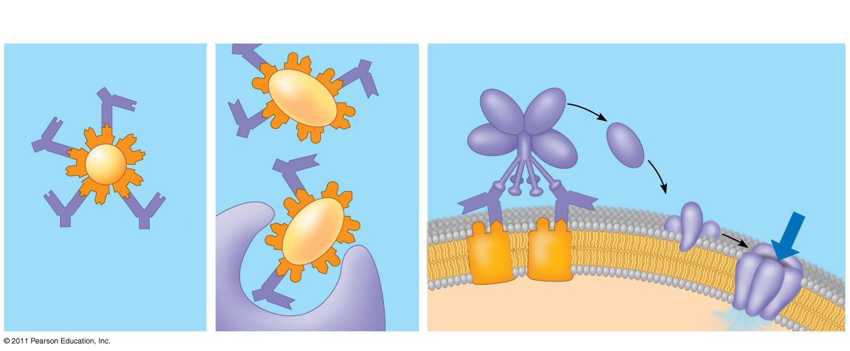

**How are ANTIBODIES structured?**

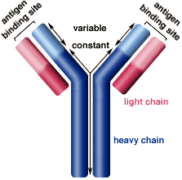

**What kinds of antibodies are there?**

B cells can express five different forms (or classes) of immunoglobulin (Ig) with similar antigen-binding specificity but different heavy chain C regions

* + ____: Membrane bound
  + ____: First soluble class produced
  + **____: only one that can cross the ________________ (involved in passive immunity); most abundant**
  + ____: found in mucous (secretory)
  + ____: involved in ____________________ reactions
* Immunizations/vaccines:
* Passive immunity:
* Allergies:
* Autoimmune Diseases:
  + Lupus, rheumatoid arthritis, Type I diabetes, multiple sclerosis
* HIV:
* Immune Rejection:
* Blood Groups:
* Tissue & Organ Transplants:
* Autoimmune Diseases:
* Immunodeficiency diseases:

