Ch. 3: Water and the Fitness of the Environment
Learning Objective: _______________ how the properties of _________ that result from its ________________ and ________________________________ affect its biological function.

- Why is water important?

- What is the “chemistry” of water?  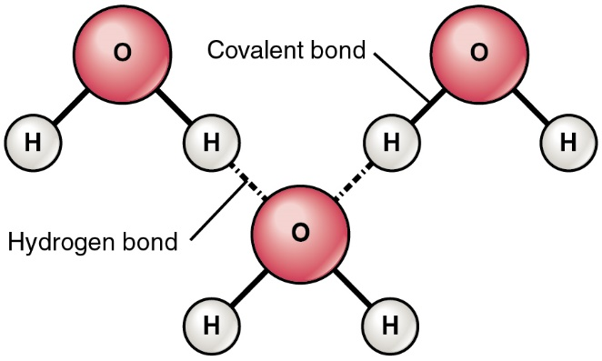  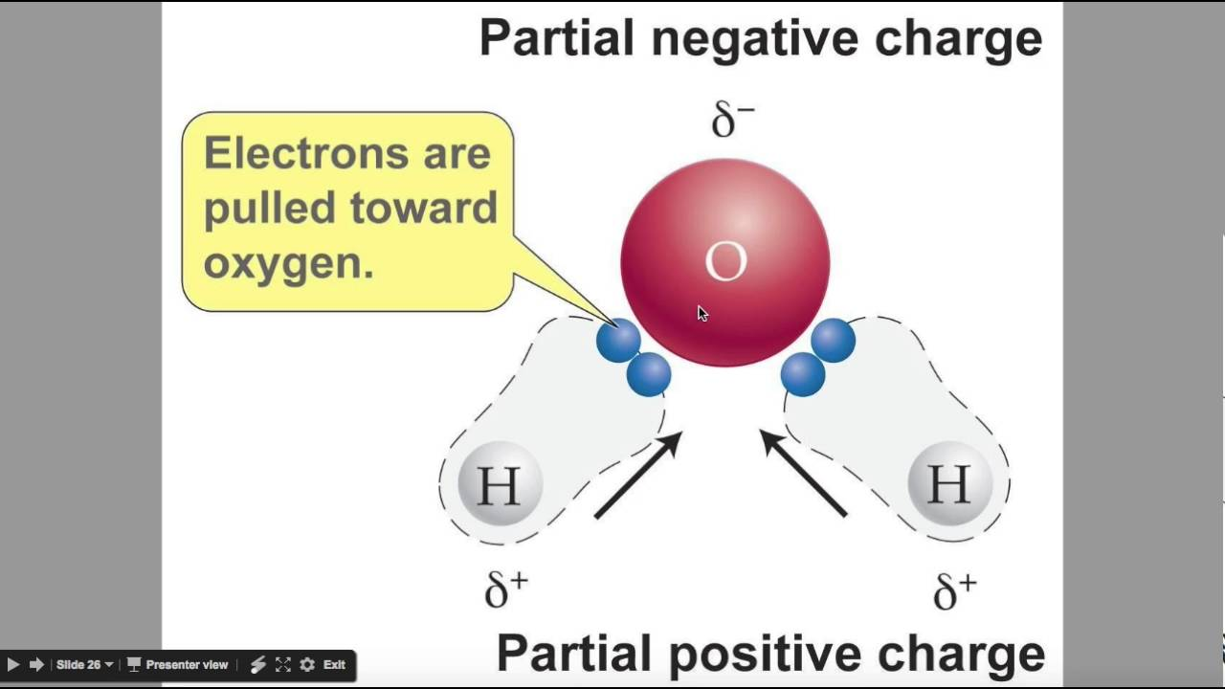 | - Water (H₂O) is made of _________________ _____________________________________  - H and O atoms are held together by _____________________________________  - Water is a ___________________ molecule meaning _____________________________ _____________________________________ _____________________________________  - One water molecule is held to another water molecule by _____________________________  - Water can form up to ________________ making water “sticky.”  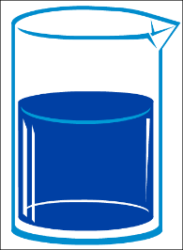  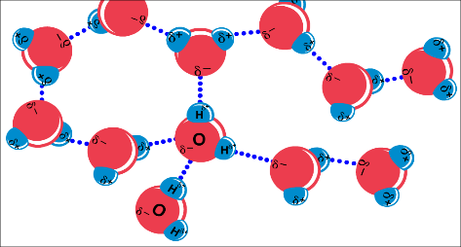
Properties of Water
- COHESION & ADHESION  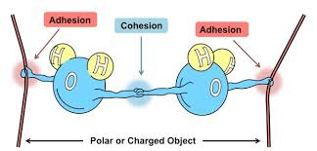  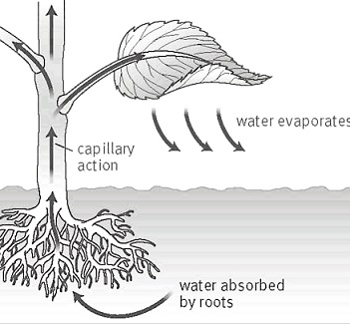 | Cohesion: ______________________________ _______________________________________  Surface tension = measure of how difficult it is to ________________________________ of liquid  - Ex:  Adhesion: ______________________________ _______________________________________  Capillary action - Adhesion of H₂O to ______ _____________________________________  - Ex: ________________________  - Ex: __________________________________  Transpiration = movement of H₂O ________ ___________________  - H₂O clings to each other by ___________________; cling to xylem tubes by ____________________
- Good SOLVENT  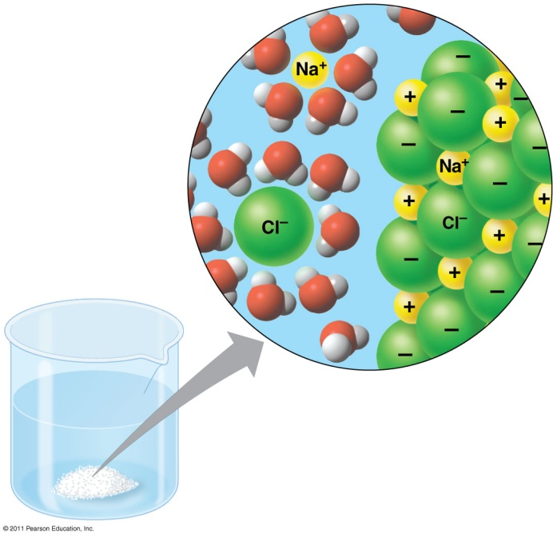  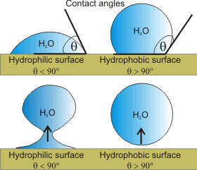 | Solvent: ____________________________  Solute: _____________________________  Solution: ___________________________  - _______________ makes H₂O a good ________________  - polar H₂O molecules surround + & – ions  - ______________ dissolve _____________ creating _____________________  Hydrophilic  - substances that _______________________ ____________________________________  - “like” water  - polar or non-polar?  - What would dissolve in water?  Hydrophobic  - substances that don’t have  an ______________________ to H₂O  - “fear” water  - polar or non-polar?  - What would not dissolve in water?
Why does it matter in a cell?
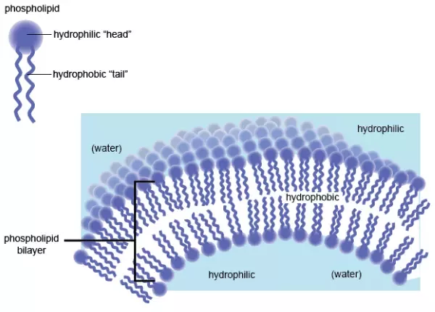

- Low Density Solid  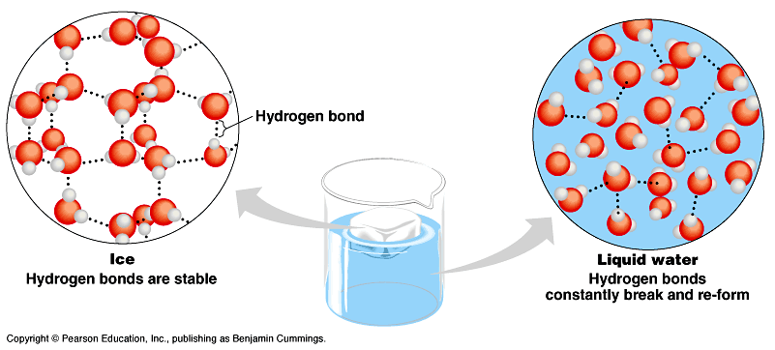 | - Why does ice float?  - Why is this important?  1.  2.  3.
- HIGH SPECIFIC HEAT | - H₂O ___________ changes in ___________________  - ____________ specific heat  - takes a _____ to _________ it up  - takes a _____ to ________ it down  - H₂O ________________________ temperatures on Earth  - Why is having a high specific heat important for life on Earth?
- HIGH HEAT OF VAPORIZATION | the amount of ___________________ (enthalpy) that must be added to a ___________________ substance, to transform a quantity of that substance into a _________  Important because of Evaporative Cooling  - Molecules with _____________ KE leave as _____  - ______________ temp in ____________________  - _____________________________  - Human _________________ (cooling)
- Ionization of water | Water ionizes:  _____ splits off from H₂O, leaving ______  - if [H⁺] = [⁻OH], water is ________________  - if [H⁺] > [⁻OH], water is ________________  - if [H⁺] < [⁻OH], water is ________________
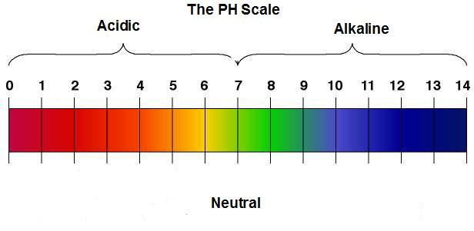  - Recall the pH scale. | - Measures how _________ or ________ solution is  - Range: ___ → ___ → ___  - Acids have an excess of _______ ions, and a pH _____________________ 7.0.  - Bases have an excess of _______(hydroxide) ions, and a pH ______________ 7.0  - What is the pH range of most living things?
- How do BUFFERS regulate pH in living things? | - Why is pH important?  - What do buffers do?
H₂O Property | Chemical Explanation | Examples of Benefits to Life
Cohesion | - polar  - H-bond  - like-like | ↑gravity plants, trees
Adhesion | - H-bond  - unlike-unlike | plants xylem  bloodveins
Surface Tension | - diff. in stretch  - break surface  - H-bond | bugswater
Specific Heat | - Absorbs & retains E  - H-bond | oceanmod temp protect marine life
Evaporation | - liquidgas  - KE | Cooling  Homeostasis
Universal Substance | - Polarityionic  - H-bond | Good dissolver  solvent

