Ch. 2: The Chemical Context of Life
Question | Notes
- What is the difference between MATTER & ENERGY? | Matter |  |  | Energy
- What is the difference between an ELEMENT & a COMPOUND? | Element  - What 6 elements are key to life?  - What are trace elements? | Compound |  |  | Molecule  -What are 4 organic macromolecules of life?
- Recall the structure of an ATOM. | - What are isotopes?
- Why are CHEMICAL BONDS important for life?  - Description  - Examples  - Relative strength | Covalent  Polar  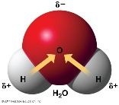  Non-polar  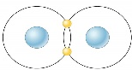 |  | Ionic |  |  | Hydrogen  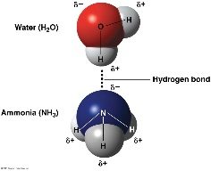
- What are components of CHEMICAL REACTIONS?

- What are ACIDS, BASES, and pH?

JIGSAW EXPERT GROUP 1:
Matter vs. Energy
- What is matter?

- What are examples of matter?

- What is Energy?

- What are examples/types of energy?

JIGSAW EXPERT GROUP 1:
Matter vs. Energy
- What is matter?

- What are examples of matter?

- What is Energy?

- What are examples/types of energy?

JIGSAW EXPERT GROUP 2:
Elements vs Compounds vs Molecules

- What is an element?

- What are examples of elements?

- What are the 6 “elements of life?”

- What are trace elements?

- What are compounds?

- What are examples of compounds?

- What are molecules?

- What are the 4 organic macromolecules of life?

JIGSAW EXPERT GROUP 3:
Atoms and Isotopes and Reactions

- What are atoms?

- What are the subatomic parts of an atom, their location, and their charges?

- What are isotopes?

- What are bonds?

- What are the parts of a chemical reaction?

- How do you write a basic equation?

- What is chemical equilibrium?

JIGSAW EXPERT GROUP 4:
Covalent vs Ionic vs Hydrogen Bonds
- Rank each bond type from strongest (generally) to weakest.

- What are covalent bonds? (strong or weak?)

- What are polar covalent bonds? An example?

- What are non-polar covalent bonds? An example?

- What are ionic bonds? (strong or weak?) An example?

- What are Hydrogen bonds? (strong or weak?)

- What are Van der Waals Interactions? Example in nature?

JIGSAW EXPERT GROUP 5:
Acids, Bases, and pH

- What is pH?

- Describe/explain the pH scale. (discuss log scale)

- What is an acid? (discuss Hydrogen ions, value on pH scale, properties)

- What is a base? (discuss Hydrogen ions, value on pH scale, properties)

- What is neutral?

- Why does pH matter?

