Ch. 25: The History of Life on Earth
Question/Learning Criteria | Answer
- Describe conditions on EARLY EARTH | How old is Earth?  When did life first appear?
- How did life arise? | - Small molecules ______________________________ (proteins, nucleic acids)  - Packaged into _____________________ (membrane-containing droplets)  - _____________________________ molecules allow for __________________  - “RNA World”:  - First catalysts =
- How did organic molecules (possibly) arise? | 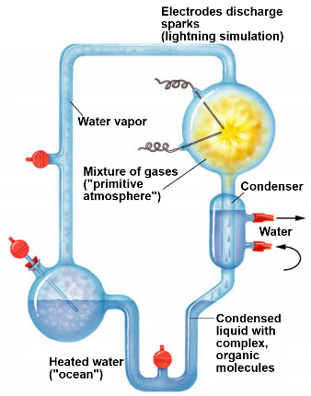  1920:  1953:
- What are Key Events in Origin of Life? | Origin of Cells (Protobionts)  - _________________________ → separate __________ from ___________  → separate _____________ from _______________
Origin of Genetics

- __________ is likely first genetic material
- multiple functions:

  - makes ______________________________ possible
  - makes ______________________________ & evolution possible

Origin of Eukaryotes
  - endosymbiosis
- How do scientists date fossils? | Relative Dating:  Radiometric Dating:
- What was the progression of the appearance of life on Earth?
- How were THE 1ST EUKARYOTES different from prokaryotes?
- What is the ENDOSYMBIONT THEORY? (Endosymbiosis) | Proposed by ________________________________  An explanation for how ________________________ evolved  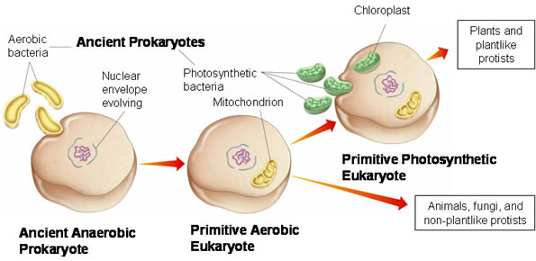
1st Endosymbiosis Event:
- origin of ________________________________
- engulfed _________________________ _____________________, but
did not digest them
- ___________________________ _______________________ relationship

2nd Endosymbiosis Event:
- origin of ________________________________
- engulfed _________________________ _________________________,
but did not digest them
- mutually _________________________ relationship

- What EVIDENCE do we have for ENDOSYMBIOSIS? | Structural  - mitochondria & chloroplasts resemble ________________________________  - mitochondria & chloroplasts have ___________________________________  - mitochondria & chloroplasts have ____________________________________
Genetic

- mitochondria & chloroplasts have their own…

Functional

- mitochondria & chloroplasts ________________________________________
- mitochondria & chloroplasts_________________________________________ ________________________________________________________________
- mitochondria & chloroplasts have their own ____________________________ ________________________________________________________________

- Why are MASS EXTINCTIONS significant in Earth’s History? | Major periods in Earth’s history __________ with __________________________ & new ones _______________ with _____________________________________
- Describe major life events in Earth’s history | Precambrian: microscopic fossils (stromatolites) | - Photosynthesis atmospheric ____  - ________________ (endosymbiont theory)
 | Paleozoic: Cambrian Explosion | - ___________ invade ___________, many ________________ appear  - Permian Extinction (-96% species)
 | Mesozoic: “Age of Reptiles”, dinosaur, plants | - Formation of Pangaea supercontinent  - Cretaceous Extinction – ______________ off Mexico’s coast
 | Cenozoic:
- Define heterochrony | evolutionary change in _____________ or _________________ of _____________________________ events. This can affect how species evolve.
- What are HOMEOTIC GENES | master _______________________ genes determine location and organization of _________________________  Ex:

