Ch. 24: The Origin of Species
Questions/Learning Criteria | Answers
- What is the difference between microevolution and macroevolution? | MICROEVOLUTION:  MACROEVOLUTION:
- What is SPECIATION?

- What is the biological definition of a SPECIES?

- Are there other definitions of a species? | - __________________________________ – by body shape, size, and other structural features  - __________________________________ – niche/role in community  - __________________________________ – share common ancestry, branch on tree of life
- How do new species originate? | - Populations must become ___________________________ (geographically and/or reproductively) and then evolve _______________________________  - Isolation may be allopatric or sympatric
- What is REPRODUCTIVE ISOLATION?
- Compare the 2 main modes of speciation | ALLOPATRIC SPECIATION  “other country” | SYMPATRIC SPECIATION  “same country”
 | - Geographically __________ populations  - Caused by geologic events or processes  - Evolves by _________________ & __________________________  - Ex: Squirrels on N/S rims of  - Grand Canyon  Draw a picture! | - _______________ populations within home range  - Gene flow between subpopulations blocked by:  - _______________________  - _____________ selection  - ___________ differentiation  Ex: polyploidy in crops  (oats, cotton, potatoes, wheat)  Draw a picture!
- Allopatric speciation can lead to ADAPTIVE RADIATION | Adaptive Radiation is when _____________ new species arise from a _______________ common ancestor  Founding Parents  Occurs when:  - A few organisms make way to new, distant areas (allopatric speciation)  - ___________________ change _______________________ new ___________________ for survivors
- Compare the types of REPRODUCTIVE BARRIERS? | PREZYGOTIC Reproductive Barriers | POSTZYGOTIC Reproductive Barriers
 | Impede _______/ _____________ | Prevent hybrid zygote from ____________ _______________
 | Types
 | - _____________________ isolation  - _____________________ isolation  - _____________________ isolation  - _____________________ isolation  - _____________________ isolation  - _____________________ isolation | - Reduced hybrid _______________  - Reduced hybrid _______________  - Hybrid _______________
- What are HYBRID ZONES? | - _____________________________________ reproductive barriers  - Possible outcomes:
- What are rates (tempos) of evolution?
 | - Common ancestor  - _________________ | - Long period of ____________ punctuated by short bursts of _____________________________
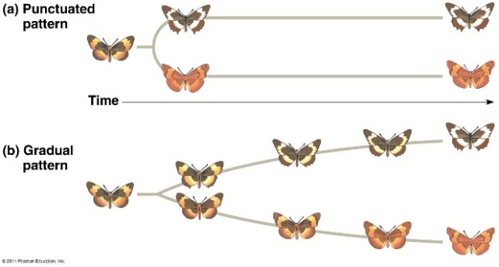
Which is it?

s

