Ch. 22: Descent with Modification: A Darwinian View of Life

Theme: Evolutionary change is based on the interactions between _______________ & their _______________ which results in ________________ (inherited characteristics) to increase ________________

Evolution = change over time in the genetic composition of a ______________________

HISTORICAL PROCESS OF SCIENCE
Aristotle: (384-322 B.C.) life-forms arranged on scale on increasing complexity (scala naturae) [simple complex]
Linnaeus: (1707-1778)
- founder of taxonomy; ____________________ _________________________
  - Domain* – Kingdom – Phylum – Class – Order – Family - Genus – Species
^{(broad)} ^{(specific)}
  - (Dear King Philip Came Over For Good Spaghetti)
  - 3 Domains = ________________________, ________________________, ________________________,
  - Classification based on anatomy & morphology
  - Binomial Nomenclature = ____________________________________ = Genus species or Genus species
    - Example: Human = Homo sapiens or _______________ __________________
    - Language = ________________________

Cuvier: (1769-1832)
- Paleontologist – studied ____________________
- Deeper strata (layers) - very different fossils from current life
- Opposed idea of evolution
- ________________________ – catastrophe destroyed many living species, then repopulated by immigrant species

Hutton / Lyell: (late 1700s)
- ___________________________________ = geologic change results from slow & gradual, continuous process
- ___________________________________ = Earth’s processes same rate in past & present therefore earth is _________________
  - Slow & subtle changes in organisms big change

Lamarck: (1744-1829)
- Published theory of evolution (1809)
- _______________________________________: parts of body used bigger, stronger
(Ex: giraffe’s neck)
- Inheritance of ____________________________ Characteristics: modifications (non-genetic changes) can be passed on
  - Importance: Recognized that species evolve, although explanation was flawed

Malthus: (1766-1834)
- More babies born than ________________
- Consequences of overproducing within environment = war, famine, disease (limits of human pop.)
- _________________________________________________
Charles Darwin (1809-1882)
- Who was he?
- Where did he travel?
- What was significant about the finches he observed?
- Who published a paper on natural selection before Darwin?
- What was Darwin’s famous publication in 1859 called?
- Darwin proposed that ________________________________________ is a _______________________ for evolution. What does this mean?

- Darwin did not use the term “evolution.” Instead he used the phrase: __________________________________

- Some of Darwin’s key points were:
  - Adaptations: enhance an organism’s ability to _______________________________________________
    - Ex: Desert fox - large ears, arctic fox - small ears
  - Overproduction of _________________________ leads to __________________________ for resources

Natural Selection | Artificial Selection
_________________ decides | “__________” decides
Works on individual | ____________ breeding
 | Inbreeding occurs
Ex: beaks | Ex: Dalmatians
Therefore, if humans can create substantial change over short time, nature can over long time.
Key Ideas of Natural Selection:
- Competition for limited resources results in ___________________________________________________ (best adapted survive better, others do not)
- ________________________________________: Individuals with more favorable ________________________ more likely to survive and produce more offspring, and pass traits to ___________________________________
- If environment changes or individuals move to new environment, new adaptations & new species may arise.
- ______________________ evolve, not individuals.

DISCUSS AND WRITE:
- How was Lamarck’s view of the mechanism of evolution different from Darwin’s?

- How was Darwin’s theory influenced by other scientists?

Ch. 22: Descent with Modification: Evidence for Evolution
Recap main ideas of natural selection:
- Evolution is change in _________________ (population) over time.
- There is ______________________________ of offspring, which leads to _______________________ for resources.
- Heritable ________________________________ exist within a population.
- These variations can result in differential _______________________________ success.
- Over ____________________________(time), this can result in changes in the genetic composition of the ____________________________________.

Evidence of Evolution:
- Direct Observations
  - Insect populations become _____________________________ to pesticides (DDT)
  - Antibiotic-resistant _________________________ (MRSA)
  - Peppered moth (pollution in city vs. country)

- Fossil Record
- Fossils = remains or traces of organisms from past
- Found in _________________________________
- _________________________: study of fossils
- Show evolutionary changes that occur over time and origin of major new groups of organisms
  - Simple Complex
  - Prokaryotes Eukaryotes
  - fish ____________________________ reptiles _______________ mammals
- Transitional forms = __________ to modern species

- Homology
- ____________________: characteristics in related species can have underlying similarity even though functions may differ (similar structure, but different function suggests common ancestor/origin
- Examples:
  - Homologous structures: similar ______________________ __________________
    - (Ex: forelimbs of human/cat/whale/bat)
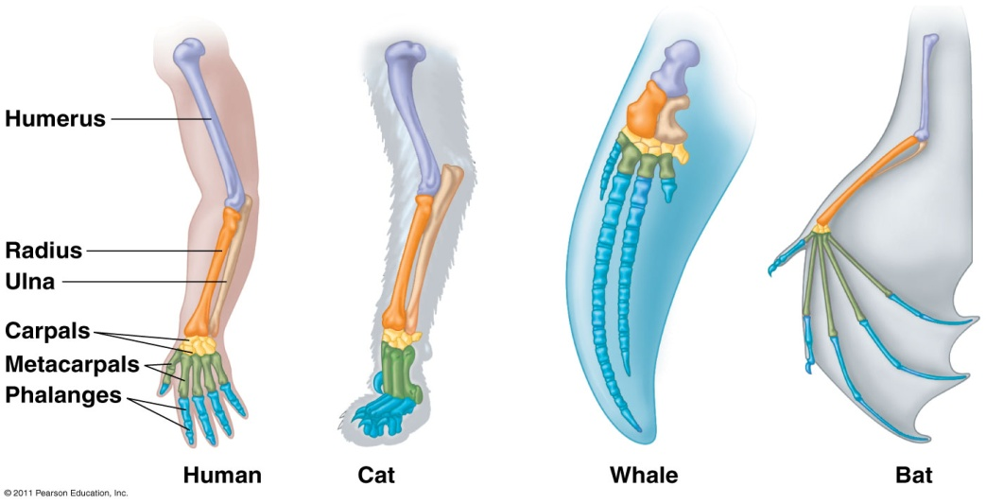

  - ______________ homologies: similar early development
    - (Ex: vertebrate embryos with tail & pharyngeal pouches)

  - ______________ organs: structures w/little or no use
(Ex: flightless bird wings, whale pelvic/leg bones, human appendix)

  - Molecular homologies:
    - compare _______ & __________________ sequences
    - Fewer differences = more recent common ancestor; greater # differences = less related

Evolutionary Trees (more on these later)
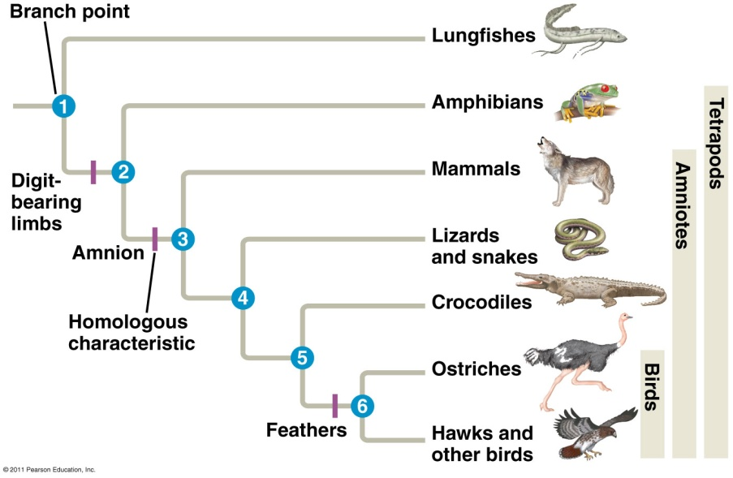
Convergent Evolution
- Distantly related organisms can resemble each other through the ______________________________ evolution of similar features in similar environments
- _____________________________structures: similar function in similar environments but not common ancestry
  - Ex: Torpedo shape of shark, penguin, & dolphin

- Biogeography
  - _____________________________ = geographic distribution of a species
  - Species in ____________________ geographic areas resemble each other
  - __________________________________________and Pangaea explains similarities on different continents
  - ___________________________ species: found at a certain geographic location and nowhere else
    - Ex: Marine iguanas in the Galapagos

