Ch. 20: Biotechnology
What you need to know:
- The terminology of biotechnology.
- How plasmids are used in bacterial transformation to clone genes.
- The key ideas that make PCR possible and applications of this technology.
- How gel electrophoresis can be used to separate DNA fragments or protein molecules.
- Information that can be determined from DNA gel results, such as fragment sizes and RFLP analysis.

VOCABULARY TERM: | What you THINK it means | What it REALLY means
- Genetic Engineering

- Biotechnology

- Recombinant DNA
- Gene Cloning
- Restriction Enzymes
- Restriction Fragment
- DNA Ligase
- Cloning Vector

Using a Restriction Enzyme to make Recombinant DNA
Notes & Questions
- Why is it necessary to cut the DNA and the “gene of interest” with the same restriction enzyme?

- How do the DNA fragments re-join?
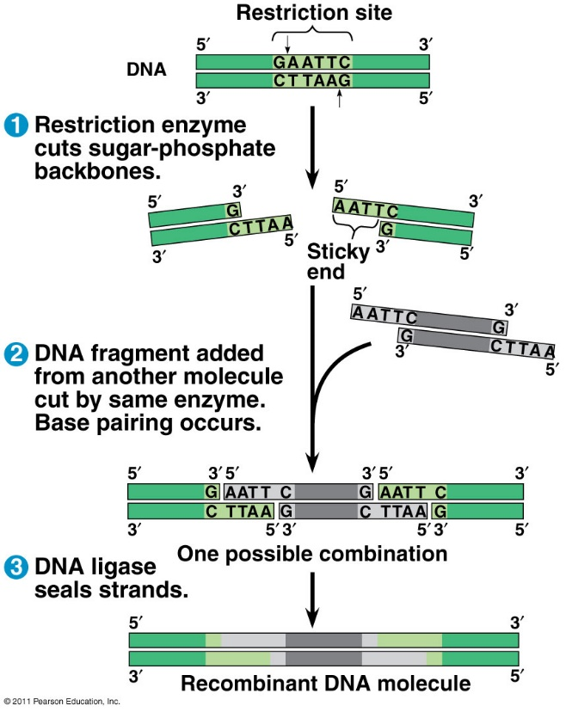

Gene Cloning
Notes & Questions
- How is the bacterial DNA plasmid cut?

- How is the bacterial DNA joined with the “gene of interest”?

- Give an example of a possible “gene of interest” and why it used in this technique?

- When the recombinant DNA plasmid (a vector) is placed back into the bacterium, the bacterium has been “transformed.” What does this mean?
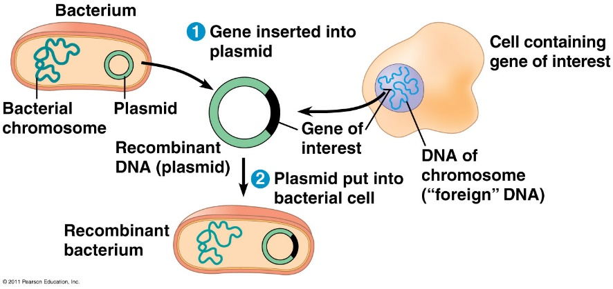

List/describe some applications of gene cloning technology:

Techniques of Genetic Engineering
PCR
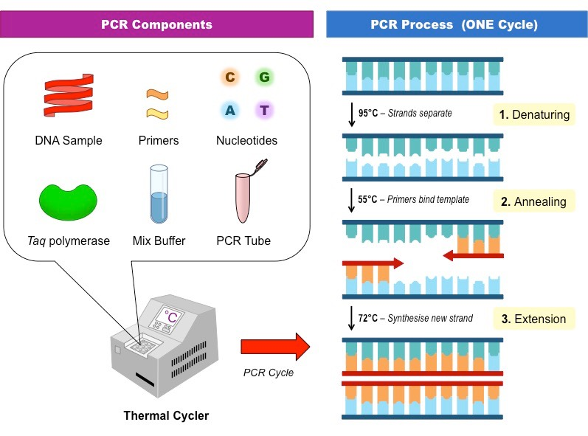

GENE THERAPY
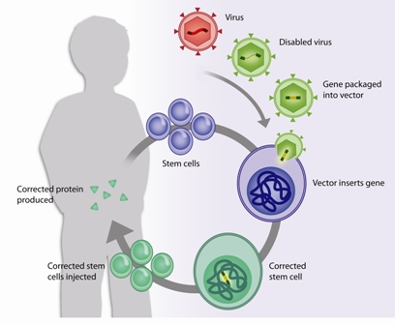

CLONING ORGANISMS
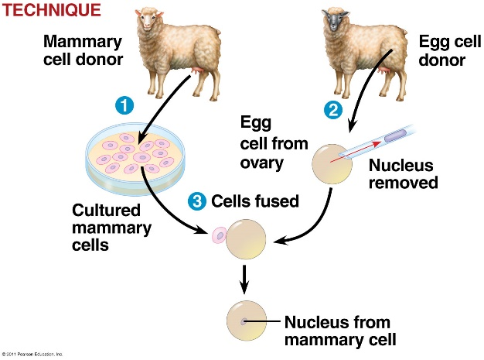

DNA MICROARRAY
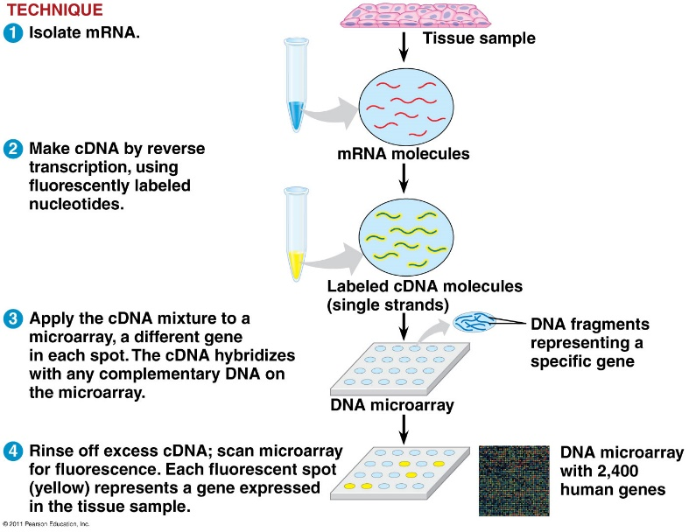

STEM CELLS
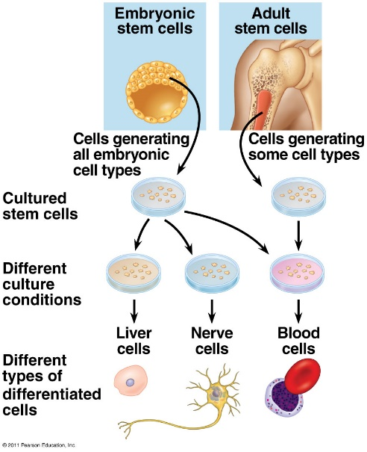

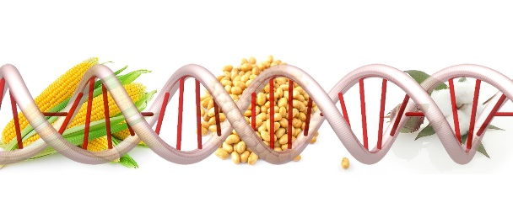
GMOs

GEL ELECTROPHORESIS & DNA FINGERPRINTING
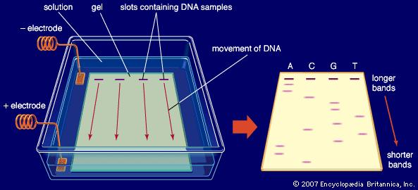

RFLPs vs STR

