Ch. 19 Reading Questions
Read Section 19.1 to answer:
- Viral envelopes can best be analyzed with which of the following techniques?
A) transmission electron microscopy
B) antibodies against specific proteins not found in the host membranes
C) staining and visualization with the light microscope
D) use of plaque assays for quantitative measurement of viral titer
E) immunofluorescent tagging of capsid proteins

- The host range of a virus is determined by
A) the enzymes carried by the virus.
B) whether its nucleic acid is DNA or RNA.
C) the proteins in the host's cytoplasm.
D) the enzymes produced by the virus before it infects the cell.
E) the proteins on its surface and that of the host.

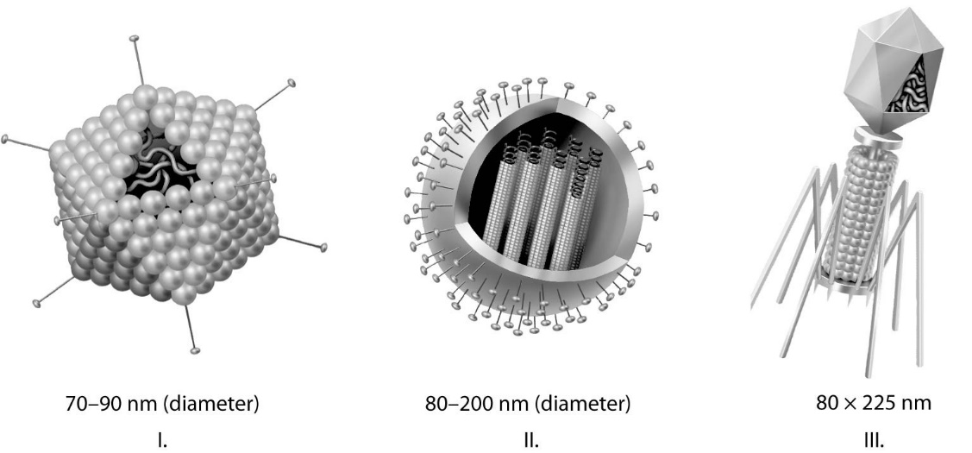
- Which of the three types of viruses shown above would you expect to include a capsid(s)?
A) I only
B) II only
C) III only
D) I and II only
E) all three

Read Section 19.2 to answer:
- Which of the following accounts for someone who has had a herpesvirus-mediated cold sore or genital sore getting flare-ups for the rest of his or her life?
A) re-infection by a closely related herpesvirus of a different strain
B) re-infection by the same herpesvirus strain
C) co-infection with an unrelated virus that causes the same symptoms
D) copies of the herpesvirus genome permanently maintained in host nuclei
E) copies of the herpesvirus genome permanently maintained in host cell cytoplasm

- Which of the following is characteristic of the lytic cycle?
A) Many bacterial cells containing viral DNA are produced.
B) Viral DNA is incorporated into the host genome.
C) The viral genome replicates without destroying the host.
D) A large number of phages are released at a time.
E) The virus-host relationship usually lasts for generations.

- Which of the following is characteristic of the lytic cycle?
A) Many bacterial cells containing viral DNA are produced.
B) Viral DNA is incorporated into the host genome.
C) The viral genome replicates without destroying the host.
D) A large number of phages are released at a time.
E) The virus-host relationship usually lasts for generations.

- Most molecular biologists think that viruses originated from fragments of cellular nucleic acid. Which of the following observations supports this theory?
A) Viruses contain either DNA or RNA.
B) Viruses are enclosed in protein capsids rather than plasma membranes.
C) Viruses can reproduce only inside host cells.
D) Viruses can infect both prokaryotic and eukaryotic cells.
E) Viral genomes are usually similar to the genome of the host cell.

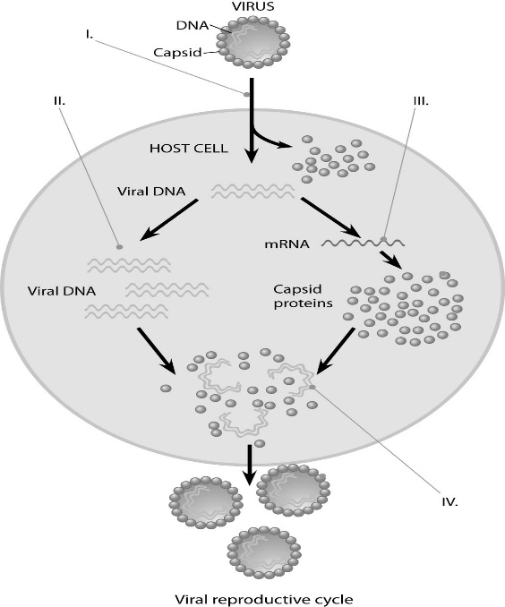
- In the figure, at the arrow marked II, what enzyme(s) are being utilized?
A) reverse transcriptase
B) viral DNA polymerase
C) host cell DNA polymerase
D) host cell RNA polymerase
E) host cell DNA and RNA polymerases

Read Section 19.3 to answer:
- Which viruses have single-stranded RNA that acts as a template for DNA synthesis?
A) lytic phages
B) proviruses
C) viroids
D) bacteriophages
E) retroviruses

- What is the function of reverse transcriptase in retroviruses?
A) It hydrolyzes the host cell's DNA.
B) It uses viral RNA as a template for DNA synthesis.
C) It converts host cell RNA into viral DNA.
D) It translates viral RNA into proteins.
E) It uses viral RNA as a template for making complementary RNA strands.

- Which of the following can be effective in preventing the onset of viral infection in humans?
A) taking vitamins
B) getting vaccinated
C) taking antibiotics
D) applying antiseptics
E) taking nucleoside analogs that inhibit transcription

- Which of the following represents a difference between viruses and viroids?
A) Viruses infect many types of cells, whereas viroids infect only prokaryotic cells.
B) Viruses have capsids composed of protein, whereas viroids have no capsids.
C) Viruses contain introns, whereas viroids have only exons.
D) Viruses always have genomes composed of DNA, whereas viroids always have genomes composed of RNA.
E) Viruses cannot pass through plasmodesmata, whereas viroids can.

- The difference between vertical and horizontal transmission of plant viruses is that
A) vertical transmission is transmission of a virus from a parent plant to its progeny, and horizontal transmission is one plant spreading the virus to another plant.
B) vertical transmission is the spread of viruses from upper leaves to lower leaves of the plant, and horizontal transmission is the spread of a virus among leaves at the same general level.
C) vertical transmission is the spread of viruses from trees and tall plants to bushes and other smaller plants, and horizontal transmission is the spread of viruses among plants of similar size.
D) vertical transmission is the transfer of DNA from one type of plant virus to another, and horizontal transmission is the exchange of DNA between two plant viruses of the same type.
E) vertical transmission is the transfer of DNA from a plant of one species to a plant of a different species, and horizontal transmission is the spread of viruses among plants of the same species.

- What are prions?
A) mobile segments of DNA
B) tiny molecules of RNA that infect plants
C) viral DNA that has had to attach itself to the host genome
D) misfolded versions of normal brain protein
E) viruses that invade bacteria
- Which of the following is the most probable fate of a newly emerging virus that causes high mortality in its host?
A) It is able to spread to a large number of new hosts quickly because the new hosts have no immunological memory of them.
B) The new virus replicates quickly and undergoes rapid adaptation to a series of divergent hosts.
C) A change in environmental conditions such as weather patterns quickly forces the new virus to invade new areas.
D) Sporadic outbreaks will be followed almost immediately by a widespread pandemic.
E) The newly emerging virus will die out rather quickly or will mutate to be far less lethal.

End-of-Chapter Questions
The following questions are from the end-of-chapter “Test Your Understanding” section in Chapter 19 of the textbook.

- Which of the following characteristics, structures, or processes is common to both bacteria and viruses?
A) metabolism
B) ribosomes
C) genetic material composed of nucleic acid
D) cell division
E) independent existence

- Emerging viruses arise by
A) mutation of existing viruses.
B) the spread of existing viruses to new host species.
C) the spread of existing viruses more widely within their host species.
D) mutation of existing viruses, the spread of existing viruses to new host species, and the spread of existing viruses more widely within their host species.
E) none of these.

- To cause a human pandemic, the H5N1 avian flu virus would have to
A) spread to primates such as chimpanzees.
B) develop into a virus with a different host range.
C) become capable of human-to-human transmission.
D) arise independently in chickens in North and South America.
E) become much more pathogenic.

- A bacterium is infected with an experimentally constructed bacteriophage composed of the T2 phage protein coat and T4 phage DNA. The new phages produced would have
A) T2 protein and T4 DNA.
B) T2 protein and T2 DNA.
C) a mixture of the DNA and proteins of both phages.
D) T4 protein and T4 DNA.
E) T4 protein and T2 DNA.

- RNA viruses require their own supply of certain enzymes because
A) host cells rapidly destroy the viruses.
B) host cells lack enzymes that can replicate the viral genome.
C) these enzymes translate viral mRNA into proteins.
D) these enzymes penetrate host cell membranes.
E) these enzymes cannot be made in host cells.

