Ch. 19 VIRUSES
Compare and contrast Bacteria and Viruses
BACTERIA | VIRUSES
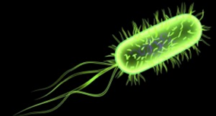

Describe and label the structure of a virus.

Viral Functioning:
- Limited __________________________________
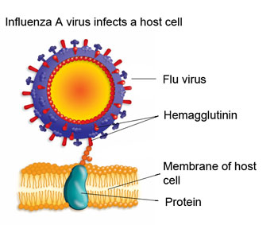
  - Entry = attach to host cell ____________________________ through ______________________________________________________
- Reproduce _____________________ within __________ cells
- Can _____________ easily
  - RNA viruses: no _________________________________________
Observe the viral pictures and descriptions on slides 8-10
- What are 2 things common to ALL viruses?

- What arrangements of nucleic acid are possible in viruses? List them.

- What type of virus is HIV?
Viral Replication
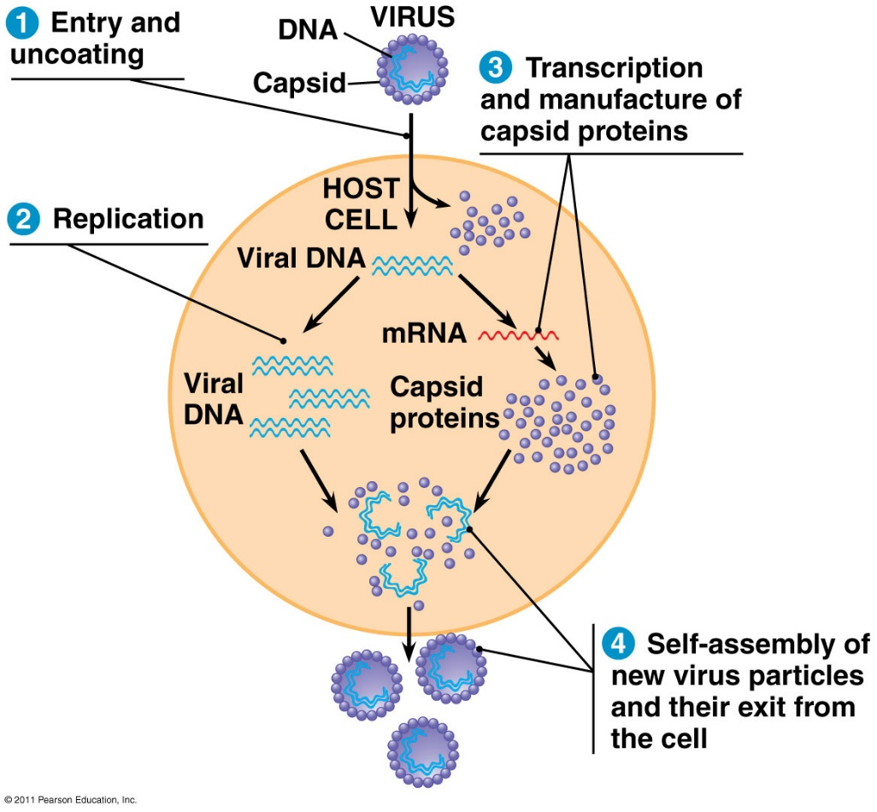
Viruses have 2 reproduction cycles. Compare them.
LYTIC CYCLE | LYSOGENIC CYCLE
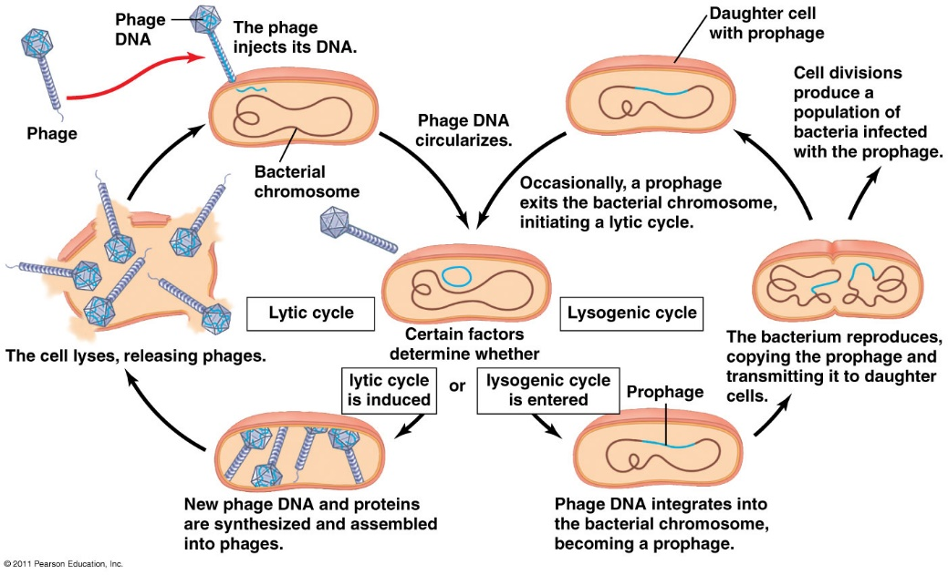
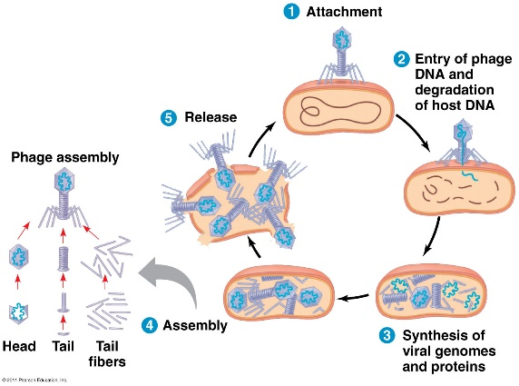
This is the ______________________ cycle

Watch the T4 Bacteriophage animation on slide 14.
- What was being injected into the host cell? _____________________
- What remained outside the host membrane? _____________________________
- What type of virus is a bacteriophage? _____________________________________________
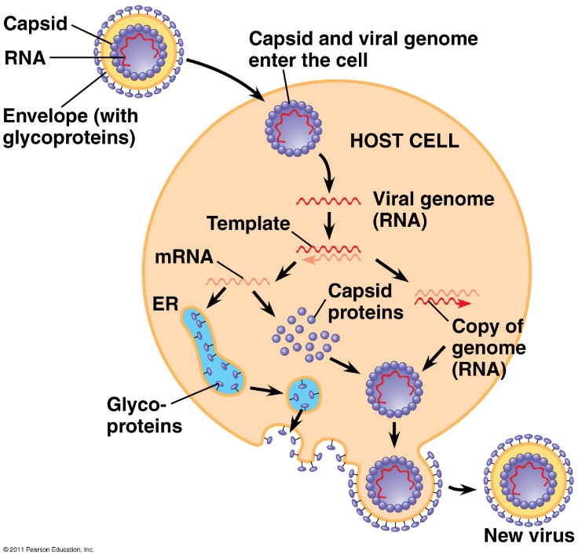
What is unique about an animal virus?

Watch the video on slide 18 on the animal virus that causes Dengue Fever. Answer these questions:
- Describe (or draw) the structural components of the Dengue virus.

- What (general) type of cell is its target host?

- How does the virus enter the host cell? What type of receptor is used?

- The virus changes the pH of the inside of the endomembrane vesicle. Use what you know about pH, protons, and proteins to explain the conformational changes that occur.

- What does the virus ultimately release into the host cell?

Watch the HIV life cycle on slide 19. Answer the questions.
- Describe the structure of the HIV retrovirus.

- What enzyme can turn RNA into DNA? __________________________________________________

- What type of host cell is the target of the HIV virus? ______________________________________

- What is the name of the unique, and defining protein receptor on the cell surface of the Helper T-cells?

- Predict: How well would the HIV virus be able to infect a cell that did not have a functional ccr5 receptor? Why?

- Notice how the cell membranes of the HIV and the host T cell fuse together. What is left outside of the host cell?

- Describe the activity of reverse transcriptase and complete the flow chart below.

ssRNA __________________ _________________

Slide 20: RETROVIRUSES:

Prevention/Treatment Drugs:

VIROIDS:

PRIONS:

Watch the Edpuzzle videos and the TedEd on Smallpox.

