Ch. 18: Gene Regulation – Part 2
How Gene Expression Regulated by Eukaryotes?
How/why can different cells in the same organism have different functions?

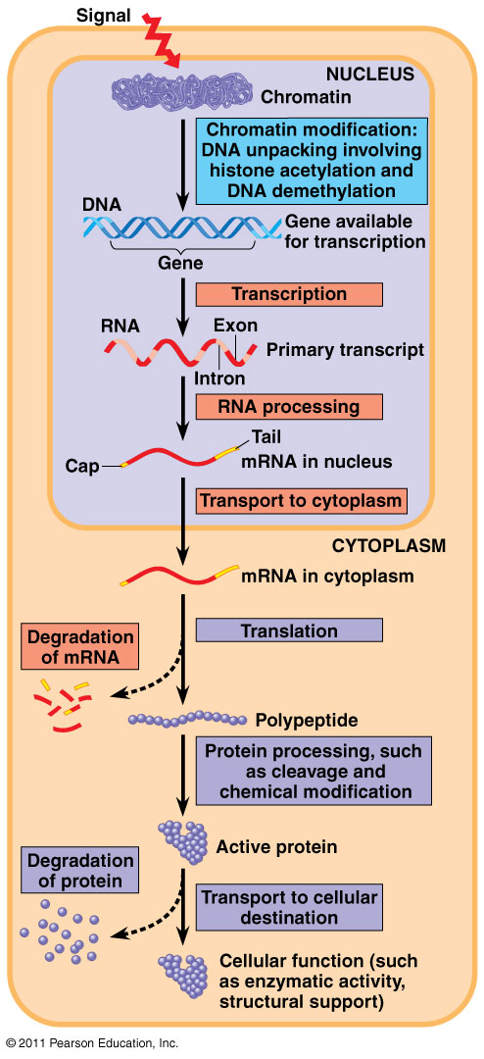
Key Point: Gene Expression in Eukaryotes is Regulated at _______________________________.
Chromatin Structure:

- Tightly bound DNA __________________________ ____________________________________________

- Heterochromatin:

- Euchromatin:

- DNA methylation:

- Histone acetylation:

1

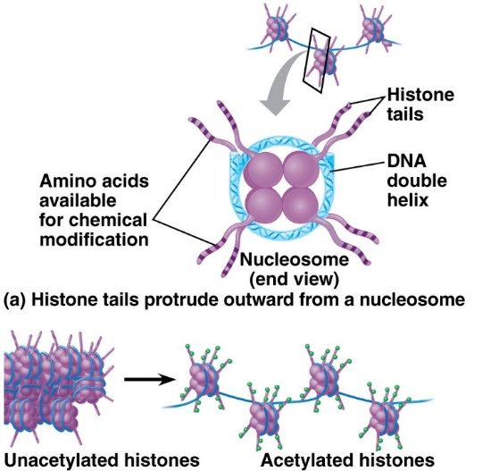

How does histone acetylation promote transcription?
____________________________________________________________________________________________________________________________________________________________________________________

What is Epigenetic Inheritance | - Modifications on chromatin can be  - Unlike DNA mutations, these changes to chromatin  - Explains differences between ___________________________________  - Eg. DNA methylation (gene silencing), histone acetylation, X chromosome inactivation, heterochromatin (silent chromatin)
v
Transcription Initiation:
- Specific transcription factors (activators or repressors) bind to

- Activators:

- Repressors:
3
2

Regulation of mRNA:
- micro RNAs (_________________) and small interfering RNAs (______________) can

- RNA processing:

- mRNA degredation:

4

Translation
- Can regulate initiation factors
5

Protein Modification/Processing

Embryonic Development of Multicellular Organisms
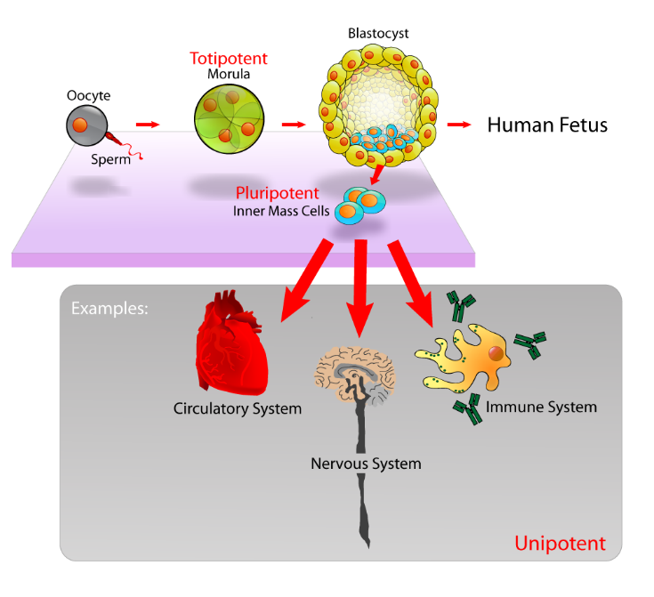
CELL DIVISION:

CELL DIFFERENTIATION:

MORPHOGENESIS:

DETERMINATION:

- Cytoplasmic Determinants:
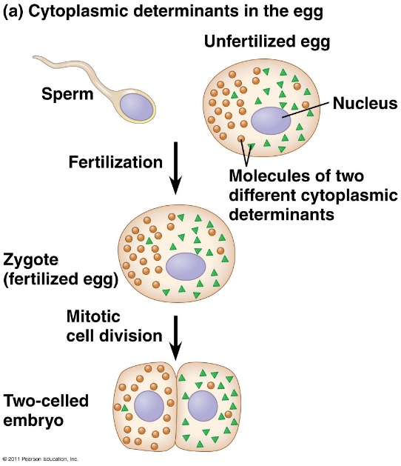

- Cell to Cell Signals:

- Induction:

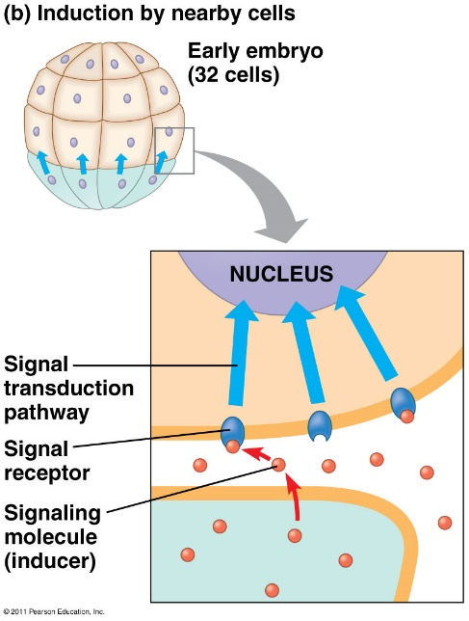
PATTERN FORMATION:

MORPHOGENS:

HOMEOTIC GENES:

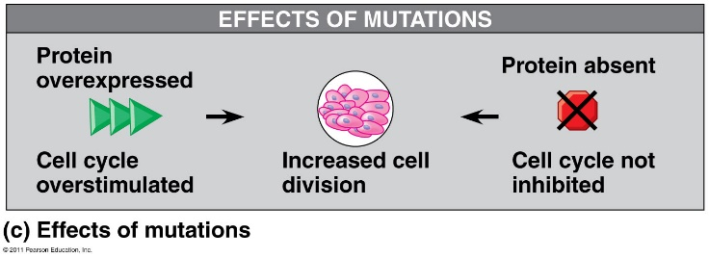
Cancer results from genetic changes that affect cell cycle control
- PROTO-ONCOGENE =

- ONCOGENE:

- TUMOR-SUPPRESSOR GENE =

Genes involved in cancer:
- Ras gene:

- P53 gene:

