Regulation of Gene Expression – Ch. 18
- Genes can be activated by inducer molecules, or they can be inhibited by the presence of a repressor as they interact with regulatory proteins or sequences.
- A regulatory gene is a sequence of DNA that codes for a regulatory protein such as a repressor protein.
- How the components of an operon function to regulate gene expression in both repressible and inducible operons.
- How positive and negative control function in gene expression.
- The impact of DNA methylation and histone acetylation on gene expression.
- How timing and coordination of specific events are regulated in normal development, including pattern formation and induction.
- The role of miRNAs in control of cellular functions.
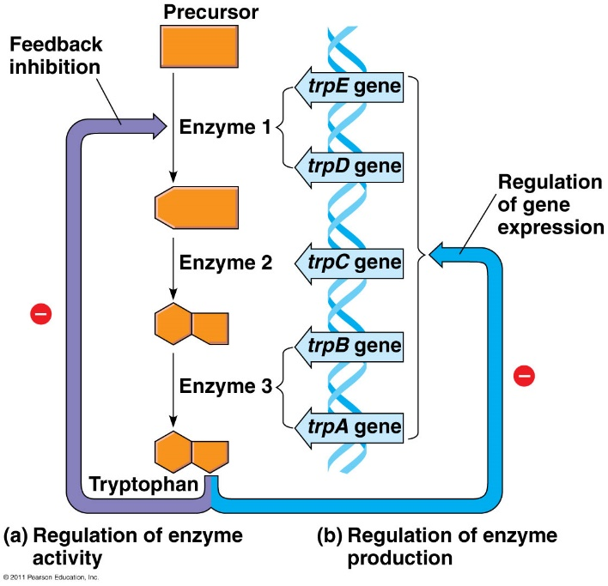
- The role of gene regulation in embryonic development and cancer.

Regulation of Gene Expression by Bacteria
- As the concentration of tryptophan protein increases, what 2 things happen to the metabolic pathway?

- Is this an example of positive or negative feedback?

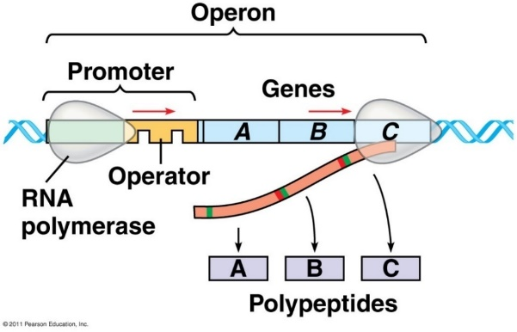
- Bacteria can respond to environmental change by regulating _________________________ (to make more or less protein/RNA)
- Bacteria have genes clustered into units called _______________.
- Operons can be regulated.
  - Turned off: _____________________ .
  - Turned on: __________________
OPERON: cluster of ________________ genes with on/off switch
Three Parts:
- P____________ – where _______________________________
- O____________ – “__________”, controls access of RNA poly
- G____________ – code for _______________________ in a pathway
Draw and label a prokaryotic OPERON

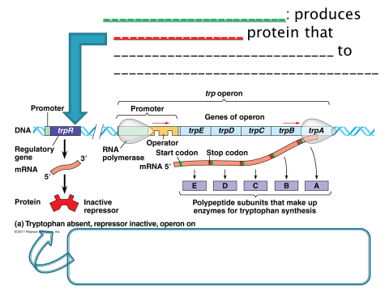

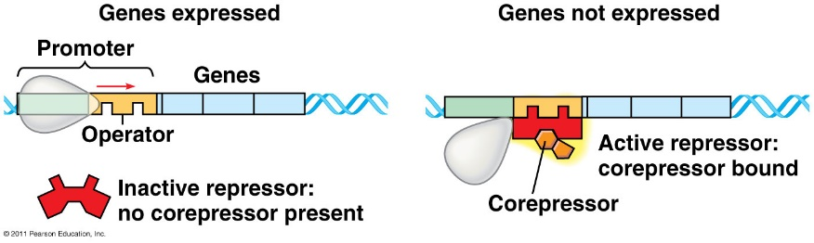
___________ OPERON (normally __ can be turned ____)
- When are the genes transcribed?

- When is the repressor inactive?

- When the corepressor is bound to the repressor, what happens?

- When is transcription off/stopped?
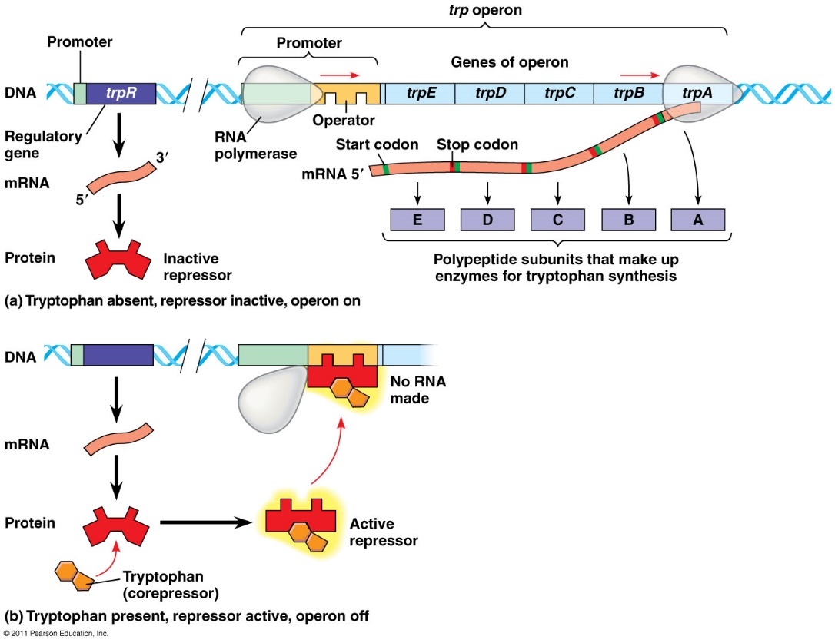

- Normally ______
- __________________ (builds organic molecules)
- Organic molecule product acts as _______________ binds to _______________ protein to __________________ it
- Operon is turned OFF
- Eg. _____ operon

- What is the co-repressor?

- How does an increase in tryptophan alter transcription (gene expression)?

Summarize why the trp operon is a repressible operon. _________________________________________________________________________________________________________________________________________________________________________________________________________

_____________ OPERON (normally ____ can be turned ___)
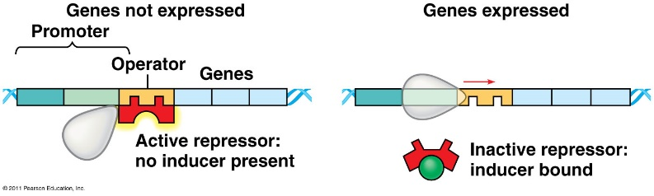
- When is transcription off/stopped?

- When is the repressor inactive?

- When the inducer is bound to the repressor, what happens?

- When are the genes transcribed?

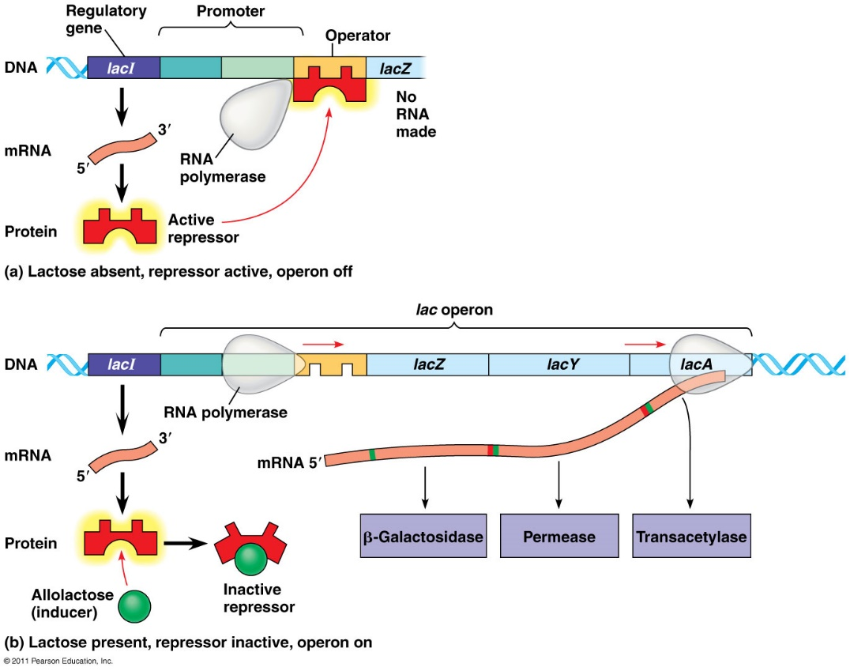
- Normally ________
- _______________ (break down food for energy)
- Repressor is active _____________ molecule binds to and ______________ repressor protein
- Operon is turned ____ and RNA polymerase can transcribe genes
- Eg. ______ operon

- What is the inducer?

- How does the inducer inactivate the repressor?

- When is the lac operon “off”?

Summarize why the lac operon is an inducible operon. ___________________________________________________________________________ ______________________________________________________________________________________________________________________________________________________

Gene Regulation: Positive vs. Negative Control
- Negative control: operons are switched _____ by active form of repressor protein
  - Eg. trp operon, lac operon

- Positive control: ___________________ protein interacts directly with genome to __________________ transcription
  - Eg. cAMP & CAP
cAMP + CAP = Positive Control
- cAMP: accumulates when _____________ is scarce
- cAMP binds to CAP (catabolite activator protein)
- Active CAP binds to ________ upstream of promoter, _______ affinity of RNA polymerase to promoter, _______ transcription
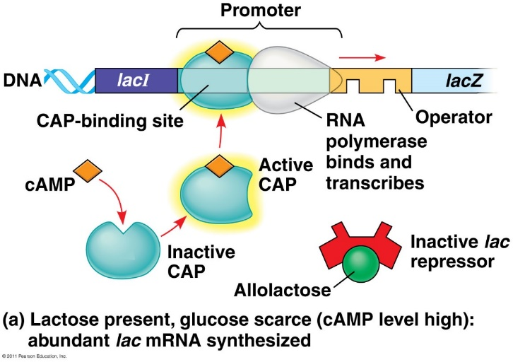
Summarize in your own words why this is an example of POSITIVE FEEDBACK CONTROL.
____________________________________________________________________________________________________________________________________________________________________________________________________________________________________________________________
- When is CAP active?

- When CAP is active, what does it do?

- When is the lac operon “on”?
  - Is it when lactose levels are high or low?

  - Is it when glucose levels are high or low?

Amoeba Sisters Video Notes: Gene Expression and the Order of the Operon

