Ch. 13: Meiosis and Sexual Life Cycles
Questions | Notes
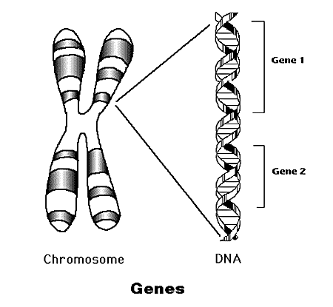
Genes:

Offspring acquire genes from parents by

 | 2 Types of Reproduction
 | ASEXUAL  - Produces  - _____________________ parent  - ____________________________ in population - only through ____________________  - ________ and _________________  - Eg. | SEXUAL  - _______________produces ______________________________  - ____ parents: male/female  - Lots of ________________________  - ___________ and _______________________________  - Eg.
Chromosomes
Somatic (body) cell:

Homologous chromosomes:

Autosomes:

Sex chromosomes:

Gametes:

 | 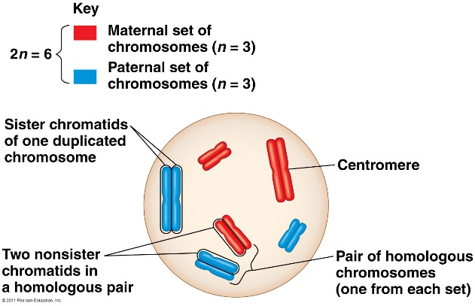
Karyotype:
During what stage of the cell cycle are the pictures usually taken of the chromosomes?

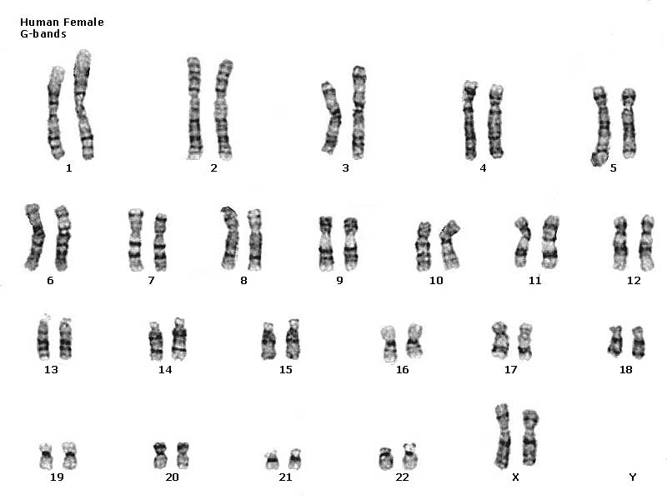
Male or Female?

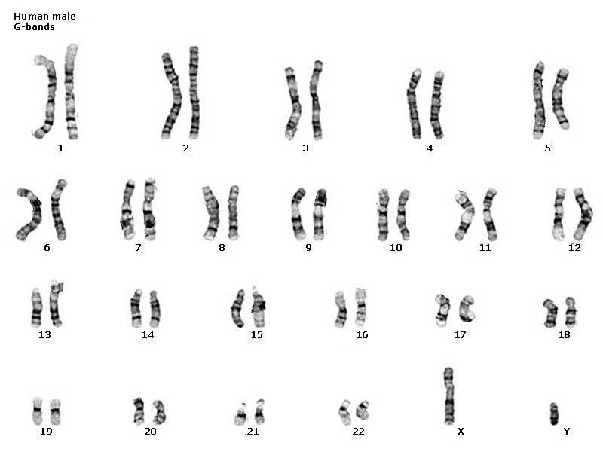
Male or Female?

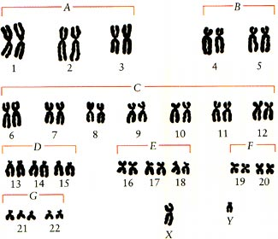
Male or Female?

Describe the “abnormality” and how it was formed.

HeLa Cells

What?

Who?

Why are they important?

SUMMARY: | I have learned
Life Cycle

_____________________ and ______________ alternate in ____________________________________

Meiosis:

Fertilization:

Human Life Cycle Animal Life Cycle

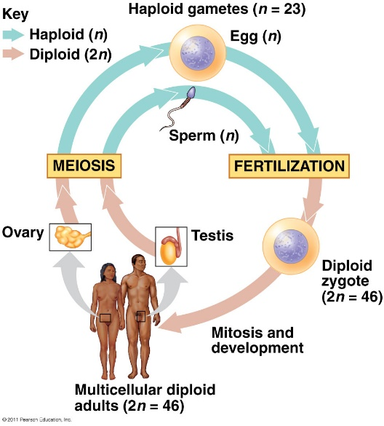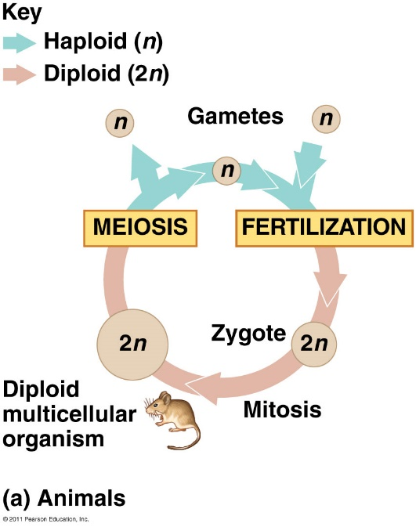
Alternation of Generations
- Plant and some algae
- Sporophyte (2n): makes _____________ _________________ by ____________
- Spore gametophyte by _______________
- Gametophyte (n): makes _____________ ________________ by ____________
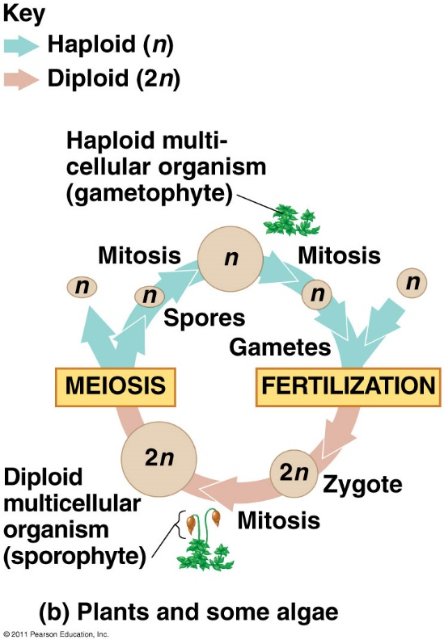
SUMMARY: | I have learned
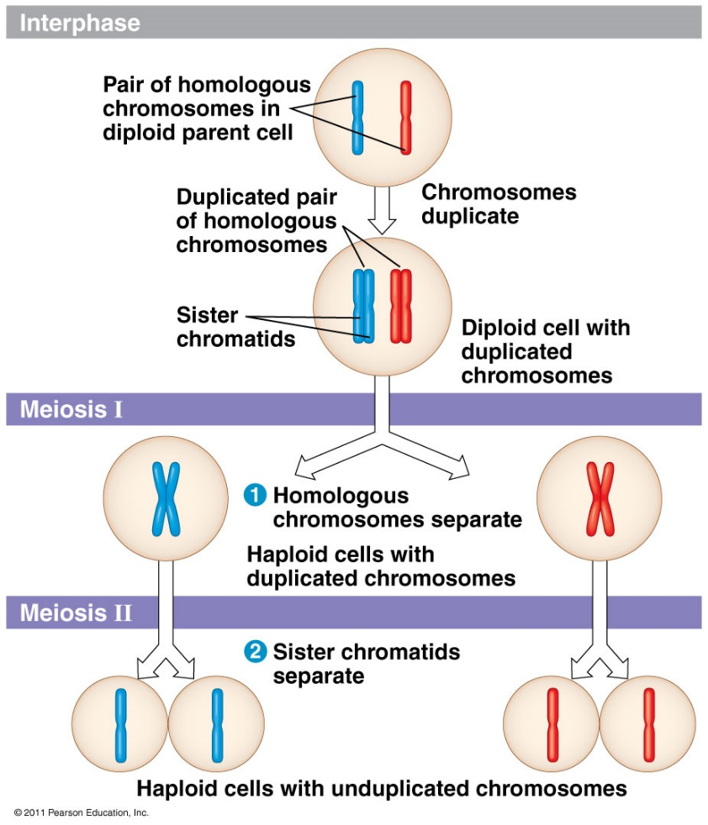
Meiosis

Cells divide __________________
Result:

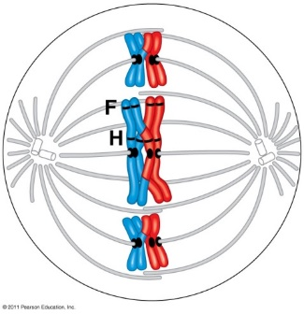
MEIOSIS I

Interphase:

Prophase I:
- Synapsis:

- Tetrad =

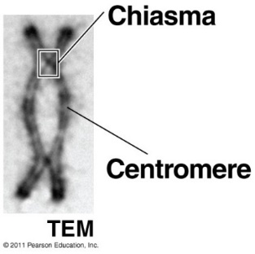
- Crossing over

Metaphase I:

Anaphase I:
- Pairs of _______________________________ separate
- (Sister chromatids still attached by ________________)

Telophase I & Cytokinesis:
- ____________________ set of chromosomes in each cell
- Each chromosome = _____________________________________________
- Some species: __________________________________________________

MEIOSIS II

Prophase II:
- No ____________________
- No ____________________
- __________________ forms

Metaphase II:

Anaphase II:

Telophase II:
- ________________________ cells
- ___________________ reappear
- Each daughter cell ___________________________

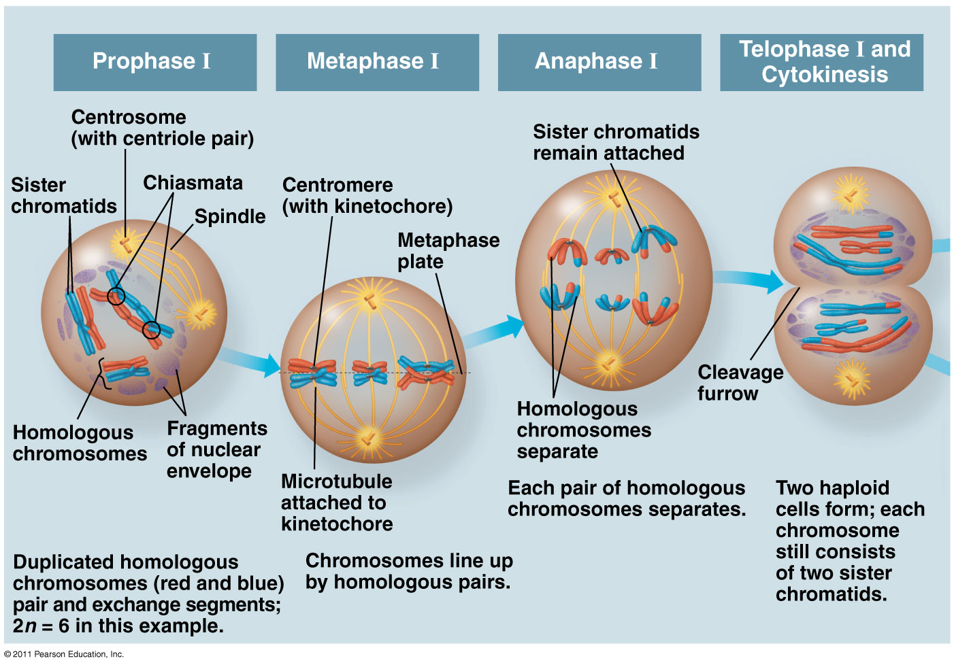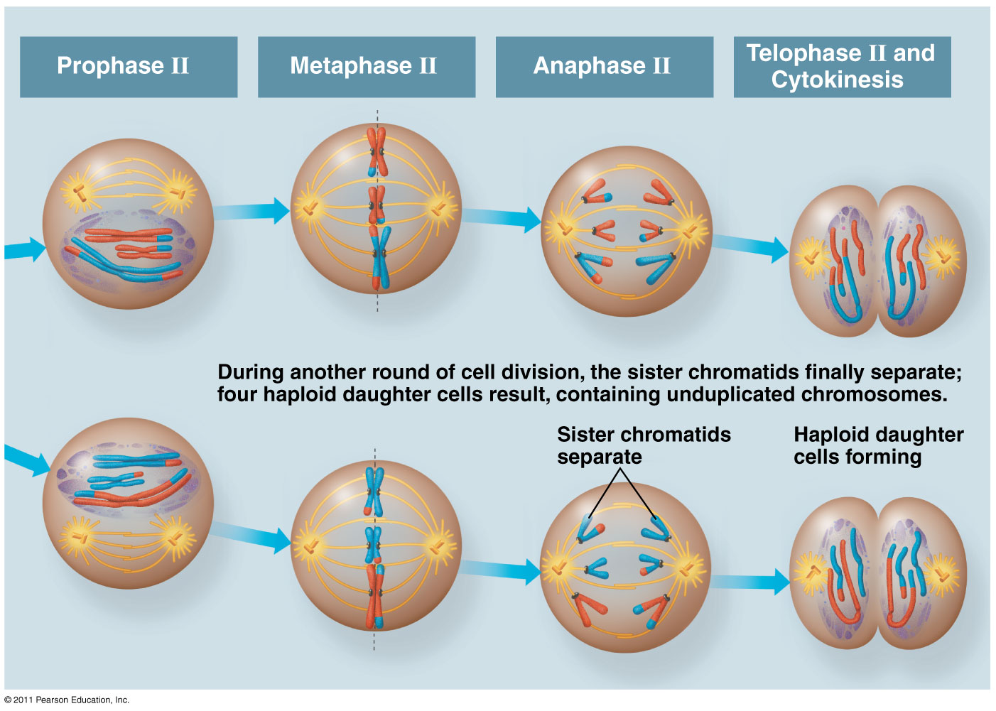

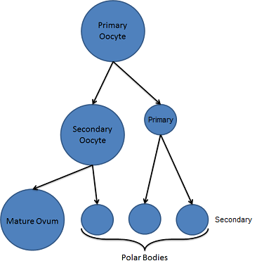
What are polar bodies?
Events Unique to Meiosis I (not in mitosis)
- Prophase I:

- Metaphase I:

- Anaphase I:

Sources of Genetic Variation
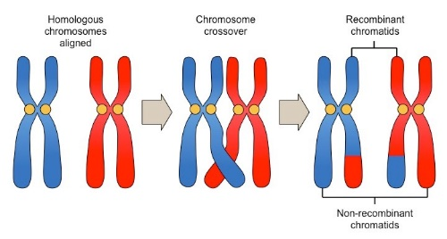
- Crossing Over:

- Independent Assortment of Chromosomes

- Random ___________________

 | MITOSIS | MEIOSIS
Both are
DNA Replication
 | - ____________________ cells  - _____ division  - ________________ daughter cells  - _________________  - From _______________ to death  - Purpose: ____________________  - No ___________________  - No _________________________ | - ___________________  - _____ divisions  - ________________ daughter cells  - Genetically __________________  - Females _________________ birth follicles are formed. ____________ released beginning _____________  - Purpose: ____________________

