Cell Communication in the Neuron
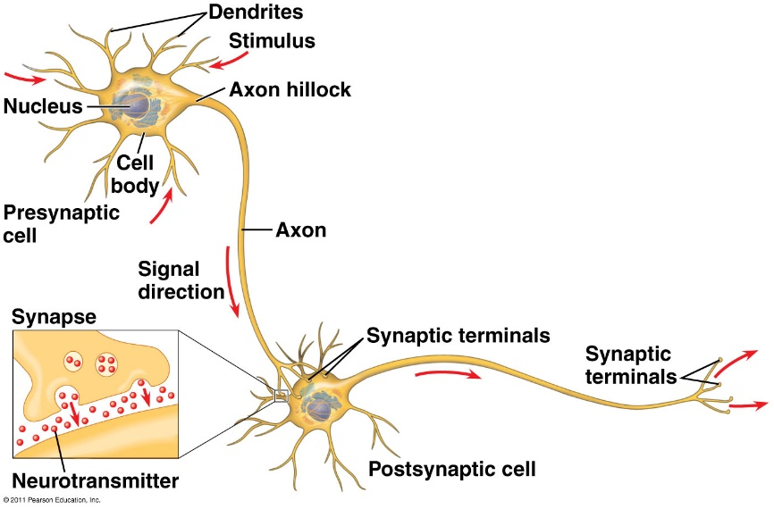

- __________________________________: contains nucleus & organelles
- __________________________________: receive incoming messages
- __________________________________: transmit messages away to other cells
- __________________________________: fatty insulation covering axon, speeds up nerve impulses
- __________________________________: junction between 2 neurons
- __________________________________: chemical messengers sent across synapse
- __________________________________: cells that support neurons
  - Eg. Schwann cells (forms myelin sheath)

The ____________________________________ (using ATP) maintains a _______________ potential inside the neuron.

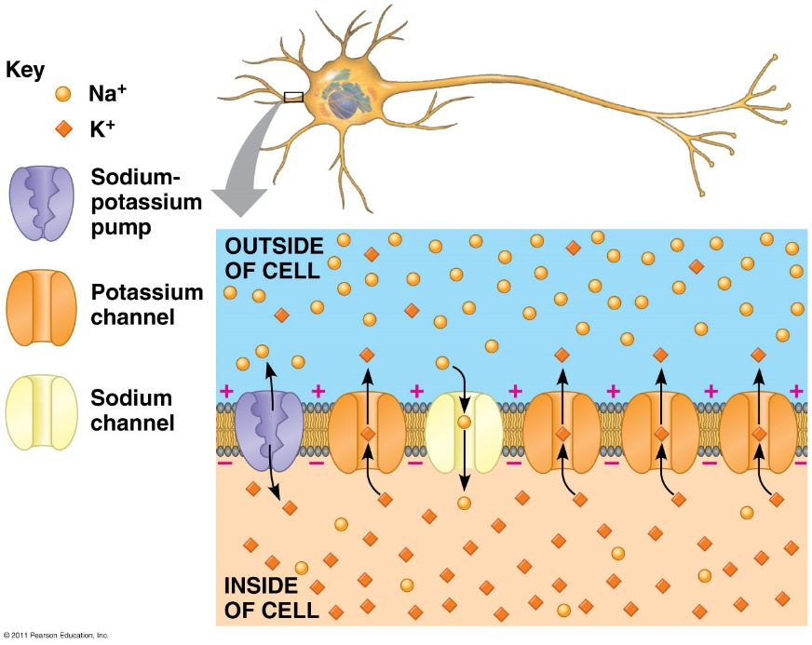

_______________________________________________________ (nerve impulses) are the signals conducted by axons
- Resting potential: membrane potential at rest is said to be _____________________________________
  - More Na⁺ ___________________, more K⁺ ___________________, cell (overall neg. charge inside axon)
  - Ion distribution is maintained by the ___________________________________________(requires ATP!)
  - _________________________________________Na⁺ channel are ____________________
- Nerve impulse: stimulus causes a change in membrane potential
  - Action potential: neuron membrane ____________________________ = becomes more _________________________ inside
  - All-or-nothing response

K⁺ channels open

Na⁺ channels open

4
- ____________________
- Na+ channels _______
- K+ channels ________ and K+ goes out
- Interior of cell becomes more _______________
3
- ____________________
- More Na+ channels _____
- K+ channels still _______
- Cell becomes more ______________ inside
2
- Stimulus _________ some ____ channels
- IF ______________ is reached, an AP is triggered

5
- ___________ ___________
- _____ channels close
1
__________ (-70mv)
_____________-gated Na+ and K+ channels ________

1
- Return to resting state
- Na+ and K+ concentrations are maintained by ____________

Saltatory conduction: nerve impulse _______________________ between __________________________________ (unmyelinated gaps) speeds up impulse

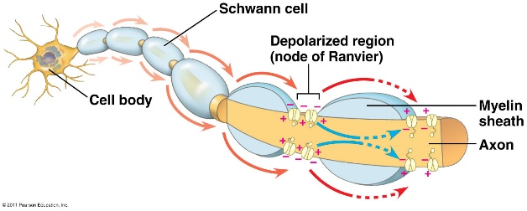

3
- Increase in Ca²⁺ causes _______________ to fuse with presynaptic membrane
- __________________________ released into synaptic cleft via ____________________
1
- ______________________ arrives
- Presynaptic membrane is ______________________

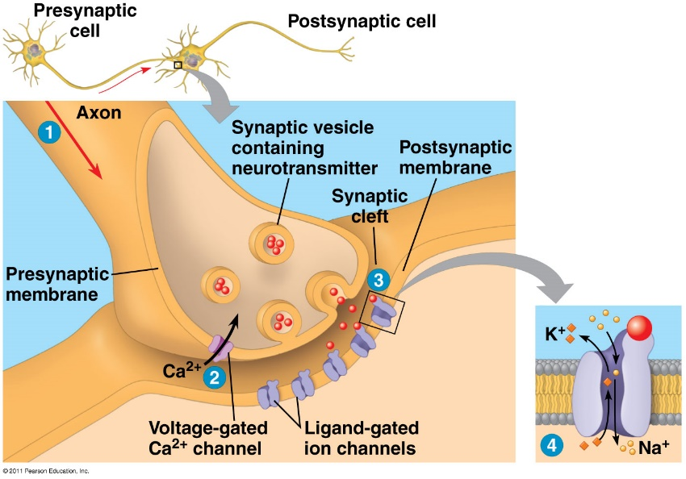
4
- Neurotransmitter binds to __________________________ on postsynaptic membrane
- Possible cell responses include:
  - Initiating depolarization and an _______________ _______________ of this neuron (excitatory)
  - ___________________ an action potential in the neuron

2
- _____________________ opens ____________ _______________________________________
- Ca²⁺ enters presynaptic cell

Neurotransmitters
- Chemicals released from vesicles by ___________________________ into synaptic cleft
- _________________________ across _________________________
- ______________ to _______________________ on neurons, muscle cells, or gland cells
- Broken down by enzymes or taken back up into surrounding cells

Types of neurotransmitters:
- Excitatory: speed up impulses by ________________________________________________________________________
- Inhibitory: slow impulses by ________________________________________________________________________

